CCCC 2018 Accessibility Lodging Quick Guide

There are three main conference hotels, all located within about a two-block radius. While we’ll provide a more expansive accessibility guide for the overall conference venue, as well as for travel and dining in the area, this quick guide is meant to give enough information to make an informed lodging decision. If you have any questions, feel free to email Abby Knoblauch (abbyk@ksu.edu) and/or Muffy Walter (muffy.walter@washburn.edu).

The primary conference hotel is the Kansas City Marriott, Downtown. This hotel is also serving as the main venue for the conference itself. However, there are two parts/towers to Kansas City Marriott, Downtown: the Marriott Main Tower portion (also often just referred to as The Marriott) and the Muehlebach Tower. Information about both are noted below. Depending on the size of the conference, there might also be sessions in the Crowne Plaza and at the conference center (about a block away).

Kansas City Marriott, Downtown
Note: This is the primary conference hotel, as well as the primary venue for the conference itself.
19.1 miles from Kansas City International Airport (MCI).
http://www.marriott.com/hotels/travel/mcidt-kansas-city-marriott-downtown/

Pros
- As the primary conference venue, this lodging option requires the least amount of travel between rooms and (most) conference panels and events.
- Many newly renovated rooms that include in-room refrigerators.
- TDD capability and TDY kits for non-accessible rooms.
- Most rooms are quite large, with large entries into in-room bathrooms.
- Room numbers have braille signage.
- Large elevators and lots of hotel staff to help with elevators. Elevators are ADA compliant.
- Entrance to the hotel has wide automatic door.
- Generally low pile carpets throughout.
- Complimentary Local-Area Shuttle (contact Front Desk for availability).
- Can access underground walkway leading to other hotels and conference center by crossing the entrance driveway and taking an elevator down one floor. Marriott entrance from parking garage is open M-F 6 am-6 pm.
Cons
- The entire hotel seems, somehow, to be scented. We originally thought it was our guide/consultant’s perfume, but it was actually just the hotel. It’s rather strongly scented, or was when we toured the hotel.
- While the elevators are large, they are operated by touch screens from the outside of the elevators only. Once you’re in an elevator, you cannot change the floor you’re going to. Instead, you have to get out of the elevator and select a new floor from the hallway outside of the elevator. The touch screens “speak,” but the hallway outside of the elevators is quite loud, so they’re difficult to hear. One has to select the floor, then wait to be directed to the elevator that will go to that floor (which is not necessarily the elevator near the touch screen that one used). This could be an issue for those with mobility, vision, or hearing issues.
- The carpet is quite busy (see photos), and the pattern changes somewhat often. The flooring between areas sometimes shifts from carpet to tile.
- The hotel does not provide an airport shuttle, however, they do utilize SuperShuttle. The fee is $18 one way.

Muehlebach Tower in Marriott Hotel
Pros
- Accessible double rooms have large sink with a cutout space, wide bathroom door, double door closet opens out into the room. Wheel in shower, fold down seat, removable showerhead, handrails around the shower walls.
- Room numbers have braille signage.
- King standard rooms are the same as in Marriot Main Tower. (See above)

Cons
- Standard double rooms have smaller turnaround space than Main Tower double rooms and the shower/tub combination has no handrails.
- While the event planner assures us that all elevators are ADA compliant, there are some serious issues with accessible elevator use. Most notably, several elevators in this tower of the hotel require employee operation.

Parking
- On site parking (for both the Main Tower and Muehlebach Tower) is $3 per hour, or $19 per day. Valet parking is $25 per day.

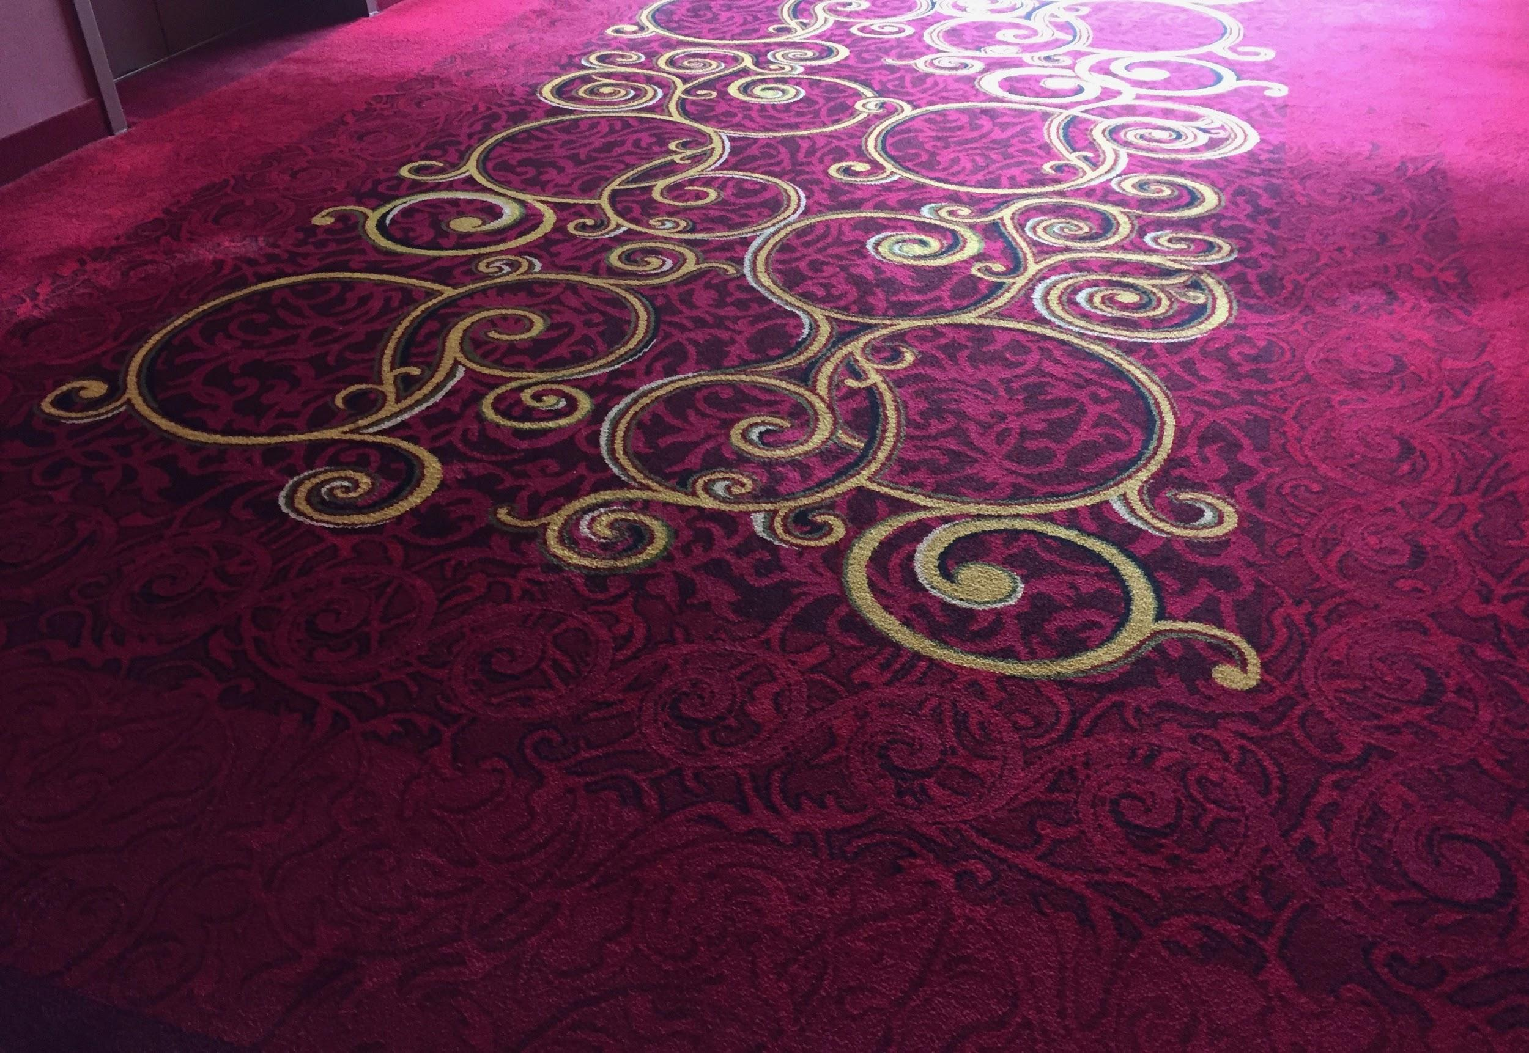
The image shows a section of carpet from the Marriott Hotel. The carpet is a mix of dark and bright burgundy with smaller lighter burgundy swirls throughout the design. There are also large gold swirls and circles in the middle of the design with white and black accents. Overall, the design is quite busy.

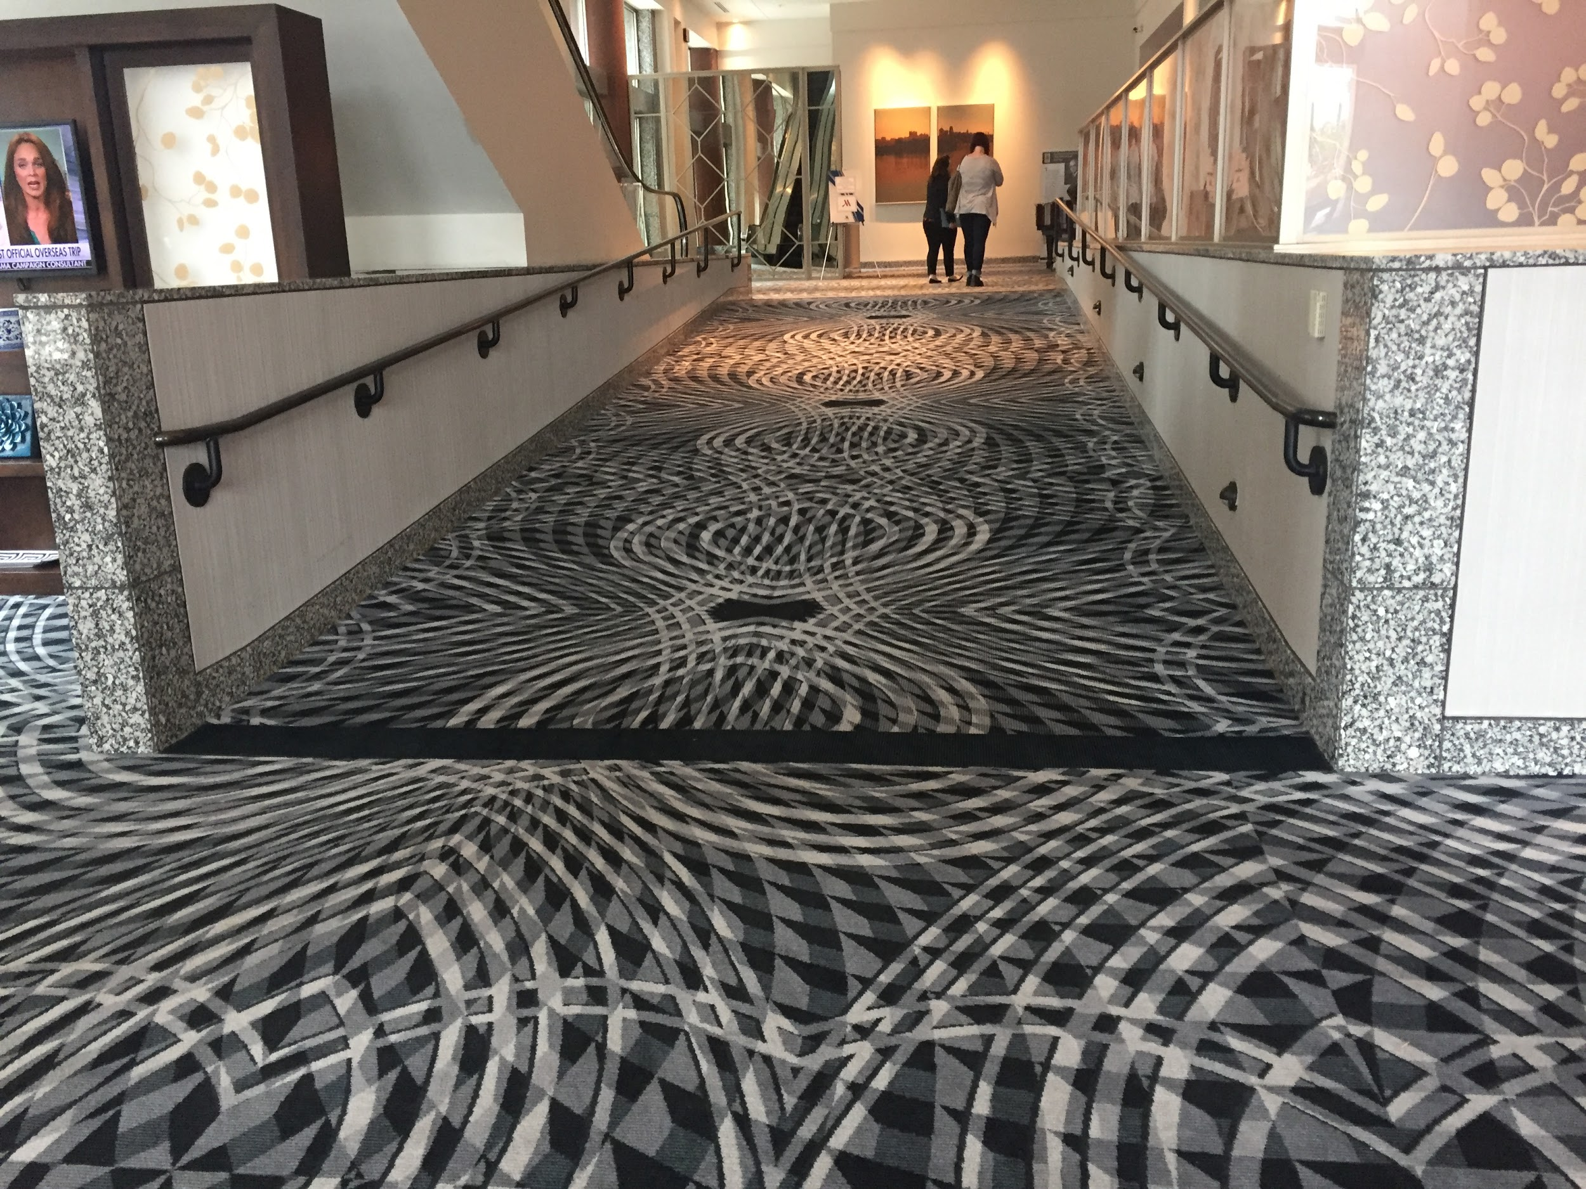
The image shows a section of carpet from the Marriott hotel. The carpet is a geometric pattern of large intersecting circles of white, black, and gray. The carpet continues up a large ramp with handrails on either side. The overall pattern of the carpet is quite busy.

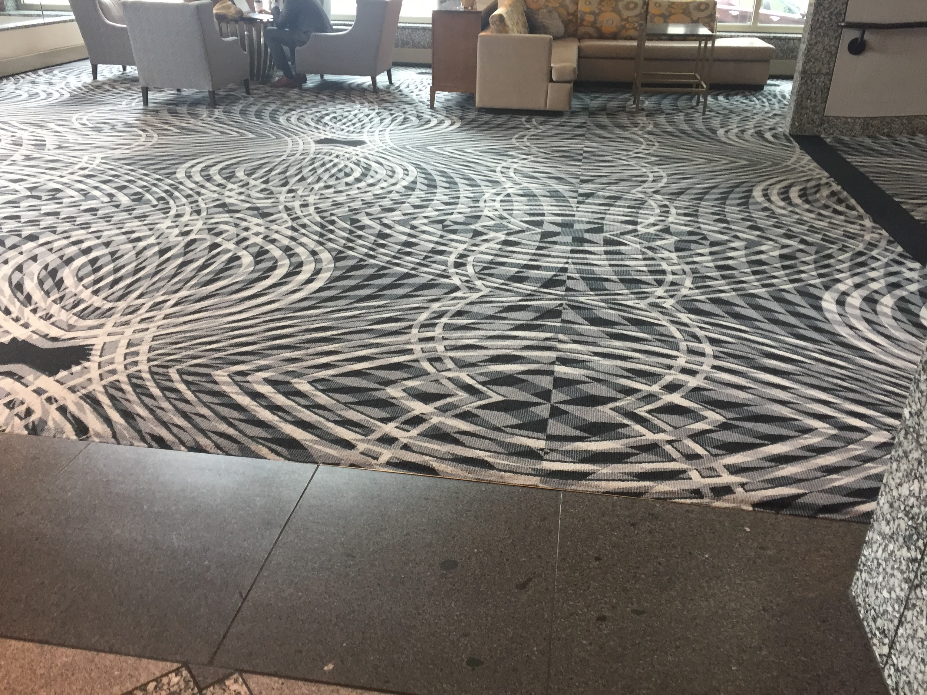
The image shows a section of flooring from the Marriott hotel. This section includes marble flooring that transitions to carpet. The marble flooring is light brown that then leads to a large dark gray strip of marble tile. The carpet is a geometric pattern of large intersecting circles of white, black, and gray. In the background are four gray armchairs around a table and a low tan sectional couch for seating. In the far right upper corner is a glimpse of the bottom of the carpeted ramp referenced in the previous image.
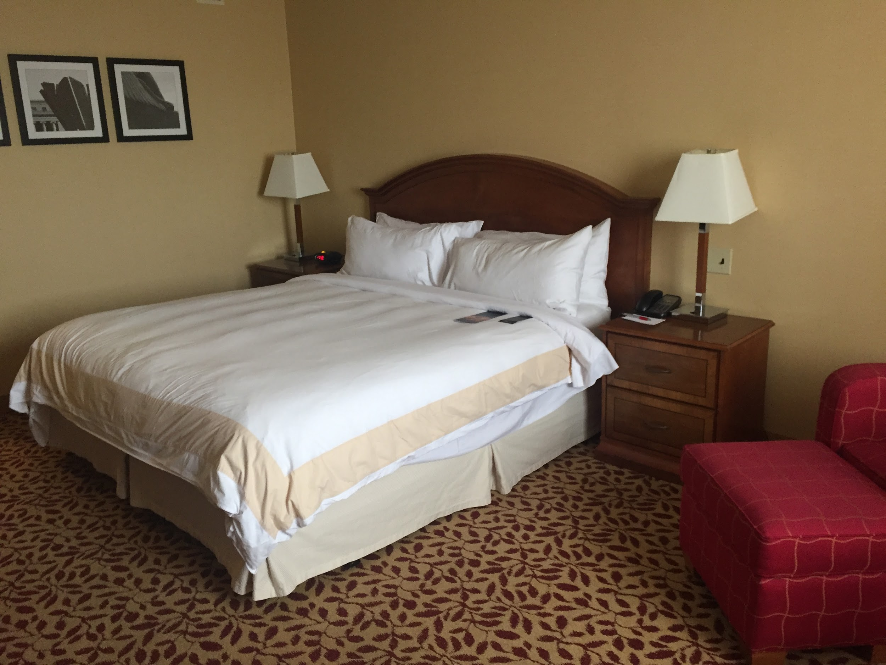
The image shows the main sleeping area of one of the rooms in the Marriott hotel. The bed is queen-sized and has a simple white comforter with a light beige stripe around the edge. There are four white pillows and a dark wooden headboard. On either side of the bed are wooden nightstands, each with two drawers, and each with a reading lamp on it. The lamps each have a squared white shade. Next to the bed is a red patterned armchair with matching ottoman. The carpet is a somewhat busy small dark red leaf pattern on a dark tan/yellow background. The walls are painted a light tan.

Aladdin (Holiday Inn Kansas City Downtown)
Note: There will not be sessions in this hotel.
22 miles from Kansas City International Airport
https://www.ihg.com/holidayinn/hotels/us/en/kansas-city/mkccc/hoteldetail

Pros
- It’s darling (& there’s a complimentary glass of champagne upon check-in).
- A total of eight accessible rooms. Accessible rooms include standing shower only option, with built-in, fold-down shower seat (see photo below). Otherwise, handrails are in bathtub/shower and at toilet.
- Window curtain “pulls” include easy to grasp handles (see photo below)
- Lower shelf in closet in accessible room.
- Room numbers have braille signage.
- Every room has a Keurig coffee maker.
- The carpeting is generally low-pile.
- Walkway to convention center and to Marriott (but see con below).

Cons
- This is an historic hotel, which means that it’s generally pretty small/narrow. The rooms are a bit small, as are the entryway, hallways, check-in area, etc. Even the accessible rooms are a little narrow.
- The rooms are quite brightly painted (bright lime green, etc.) and the carpet/flooring pattern is a bit busy (see photos below).
- There’s only one accessible elevator. The other two elevators can (maybe?) accommodate a wheelchair, but likely only a single wheelchair. Also, anyone can use the only accessible elevator, so someone in a wheelchair or scooter might end up waiting.
- The entryway includes both marble and carpet, and a small strip of flooring trim between tile and carpet.
- The in-house restaurant is not fully wheelchair accessible. Much of the seating is at the bottom of two to three steps.
- The business center and fitness center would have trouble accommodating a standard-size wheelchair.
- While there’s a walkway to the Marriott, it’s not fully accessible: it’s quite long and includes double doors that do not have accessible activation switches/push buttons. If accessing the walkway from the parking garage, there are steps that one would have to navigate. The doors at the end of the walkway to the Marriott are locked 6 p.m. to 6 a.m. Monday-Friday and are locked throughout the weekend.
- There is access to parking, but some floors include negotiating a step-up off the parking garage floor and toward the elevator.
- The hotel does not provide a shuttle to/from the airport, but SuperShuttle does service this hotel for approximately $20 each way.

Parking
- Valet parking is $18 per car per day for overnight guests.
- While self-parking is technically available, it’s at the garage across the street. Guests will be charged each time they leave and return to the parking garage.

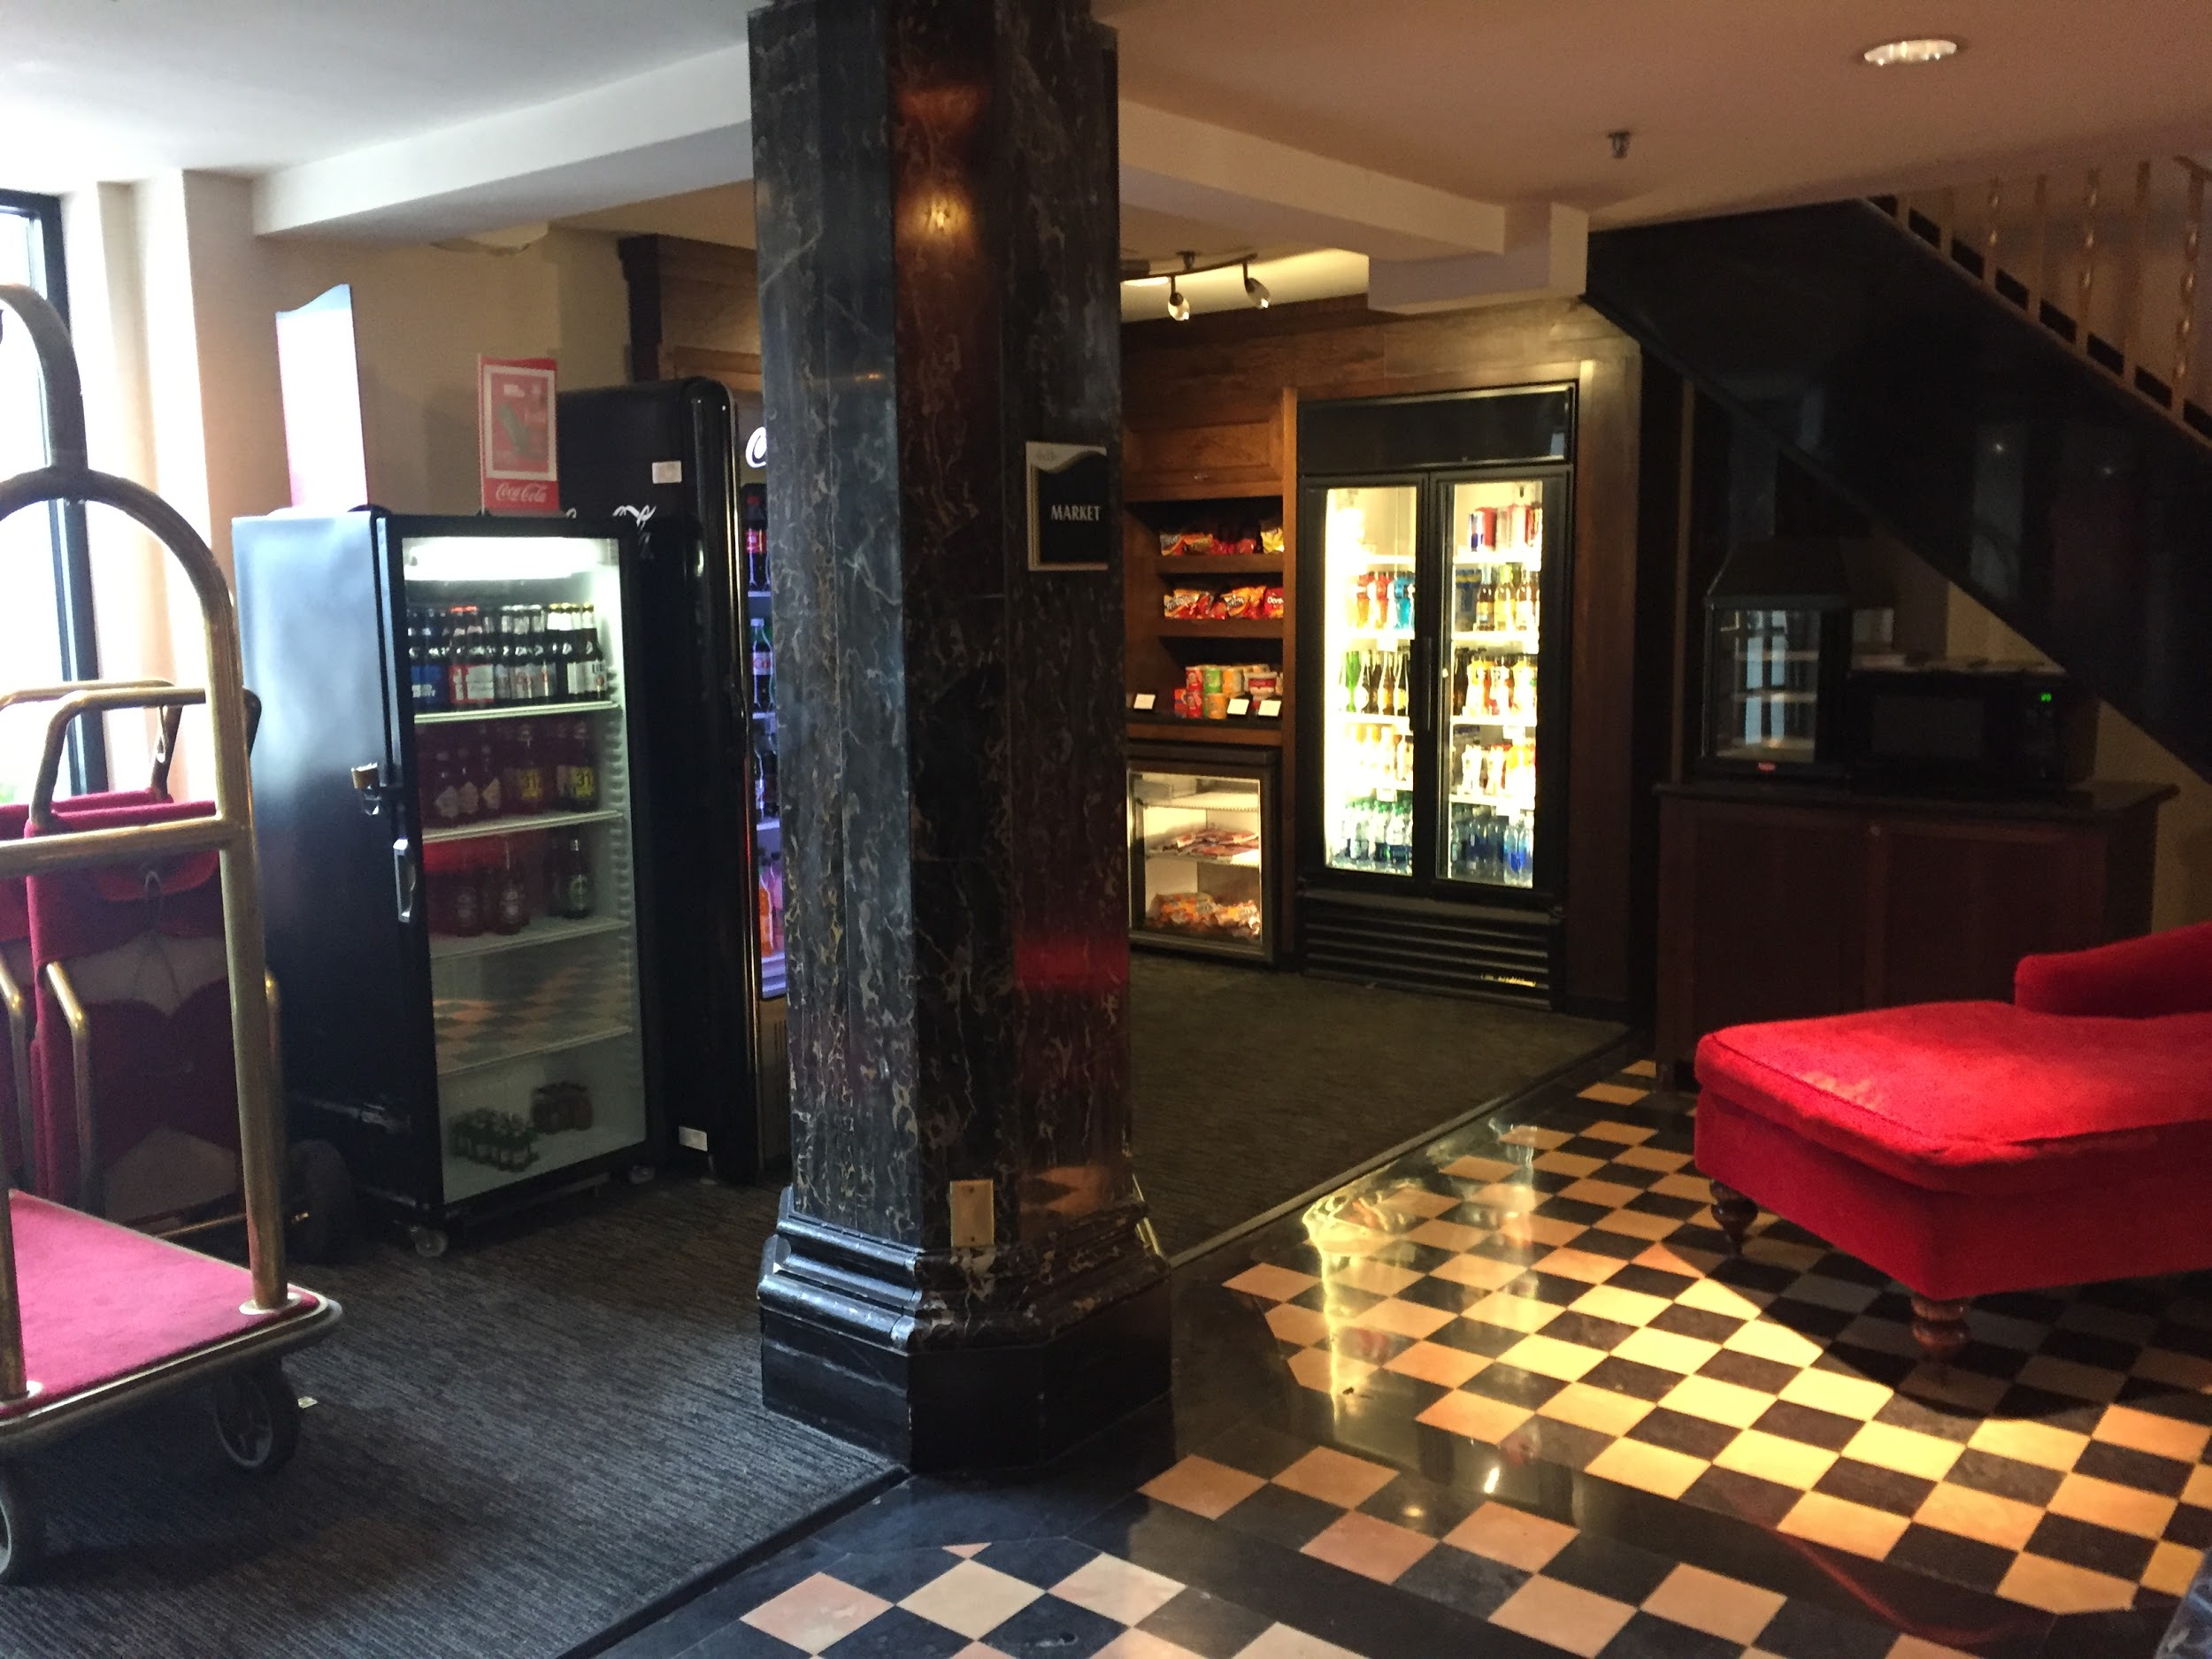
The image shows part of the entryway of the Aladdin hotel. Near the center of the image is a large black marble pillar. To the left is a bellhop cart; next to that, behind the pillar, is a convenience store style cooler with (beer?) bottles in it. Next to the cooler is the edge of a soda vending machine. Behind the pillar against the back wall are shelves and more coolers with snacks and beverages. To the right of the pillar is a bright red chaise lounge. The flooring is a mix of carpet and tile. To the left is dark gray carpet. To the right, there’s black and white checkered marble flooring. There is a black flooring strip to separate the two kinds of flooring. In the background are stairs leading to the second floor. The paths between objects in the entryway are somewhat narrow.
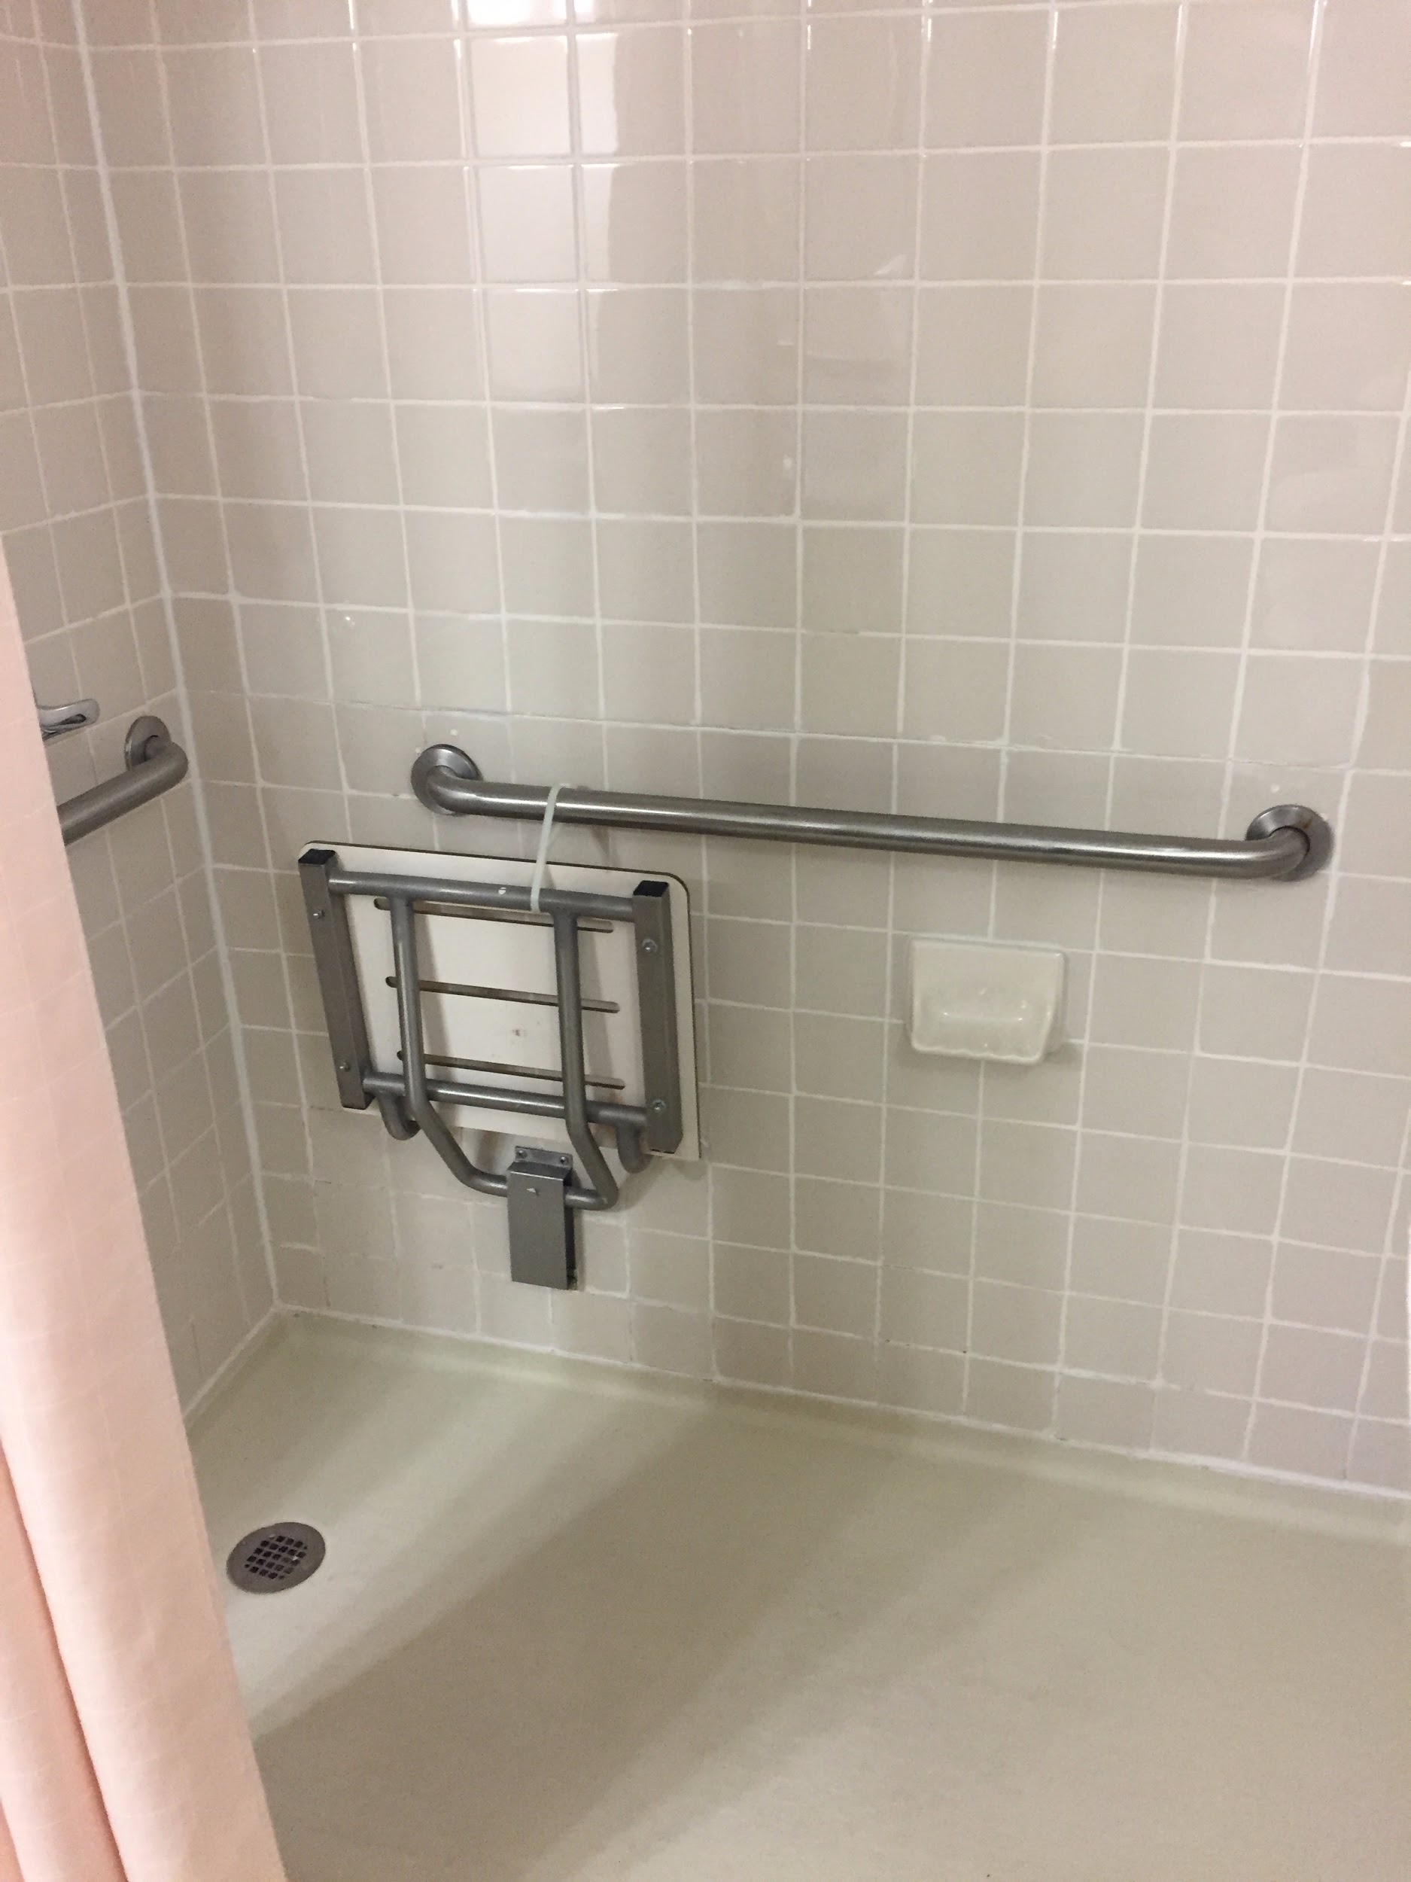
The image shows the inside of one of the accessible shower stalls at the Aladdin hotel. A built-in shower seat that folds up or down is in the up position, secured by a white zip-tie to a silver handrail inside the shower. Beneath the handrail is a white soap holder. A second silver handrail is visible in the upper left corner. The shower is gray tile with white grout and a light pink shower curtain is drawn back to reveal the inside of the shower.
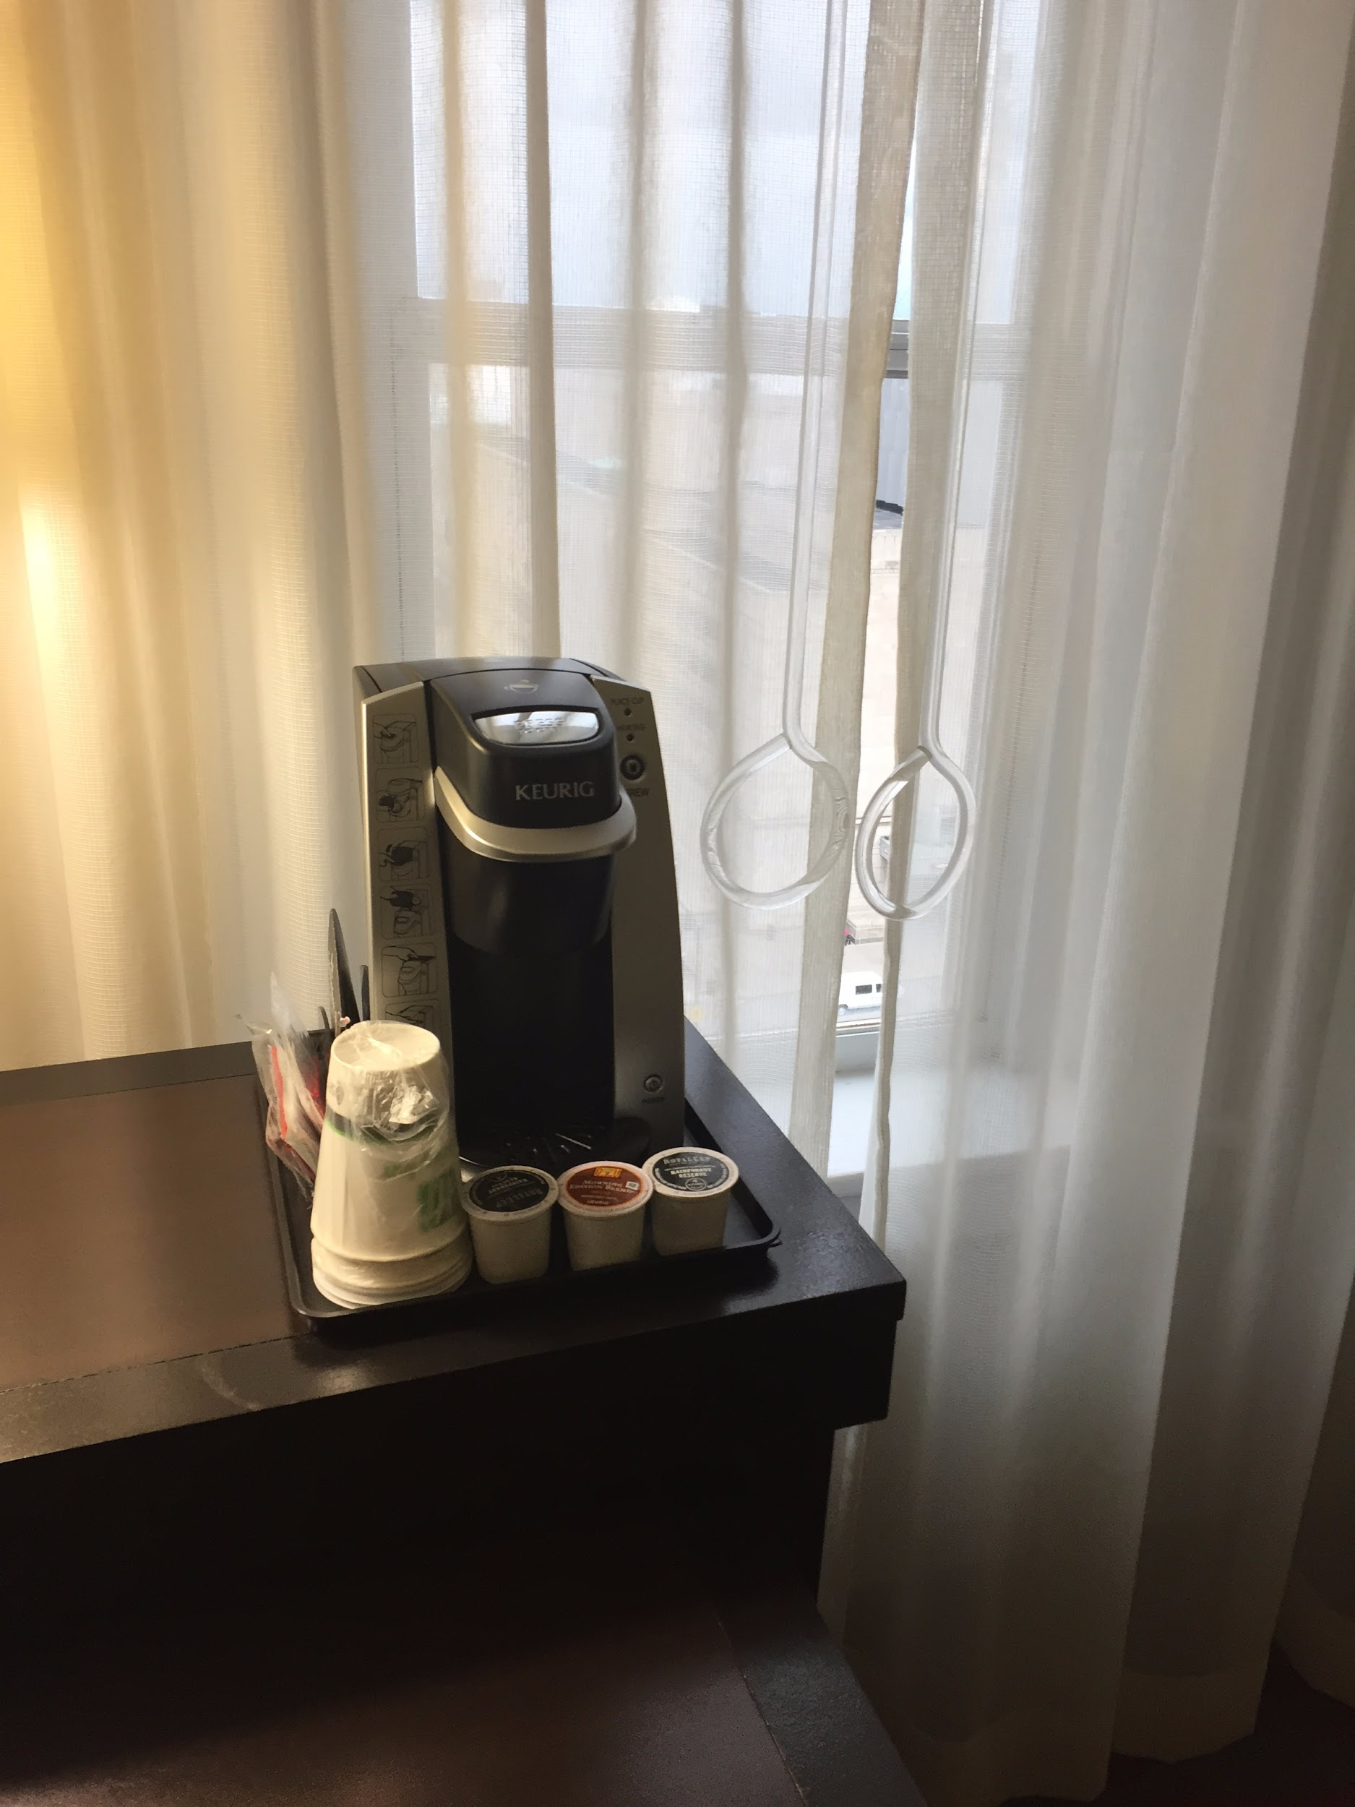
The image shows a Keurig coffee maker in one of the accessible rooms at the Aladdin hotel. The coffee maker is black, sitting on a tray, and in front of it are three coffee pods and a small stack of paper cups wrapped in plastic. There are also various packets (likely sugar?) next to the coffee maker. Next to the table on which the coffee maker sits is a window with sheer white curtains that are shut. The curtain rod is clear plastic and ends in a large circle for easier gripping.

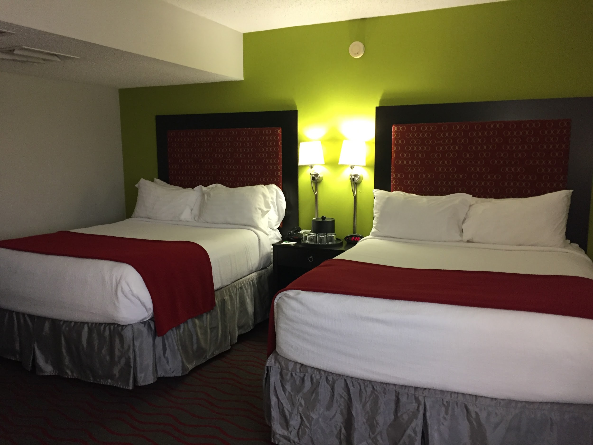
The image is of one of the rooms at the Aladdin. There are two full sized beds, each with a simple white comforter and a maroon blanket folded across the foot of the bed. Each bed has four white pillows. Each also has a dark gray dust ruffle and a dark headboard with a maroon cushioned insert with small tan/yellow vertical dashes throughout. The inserts make up most of the space of the headboards. Between the two beds is one night stand on which sits a small ice bucket and four small water glasses. There is a smallish lamp on either side of each bed on the nightstand and the lamps are on. The room itself is somewhat dimly lit, and the walls are painted bright lime green.

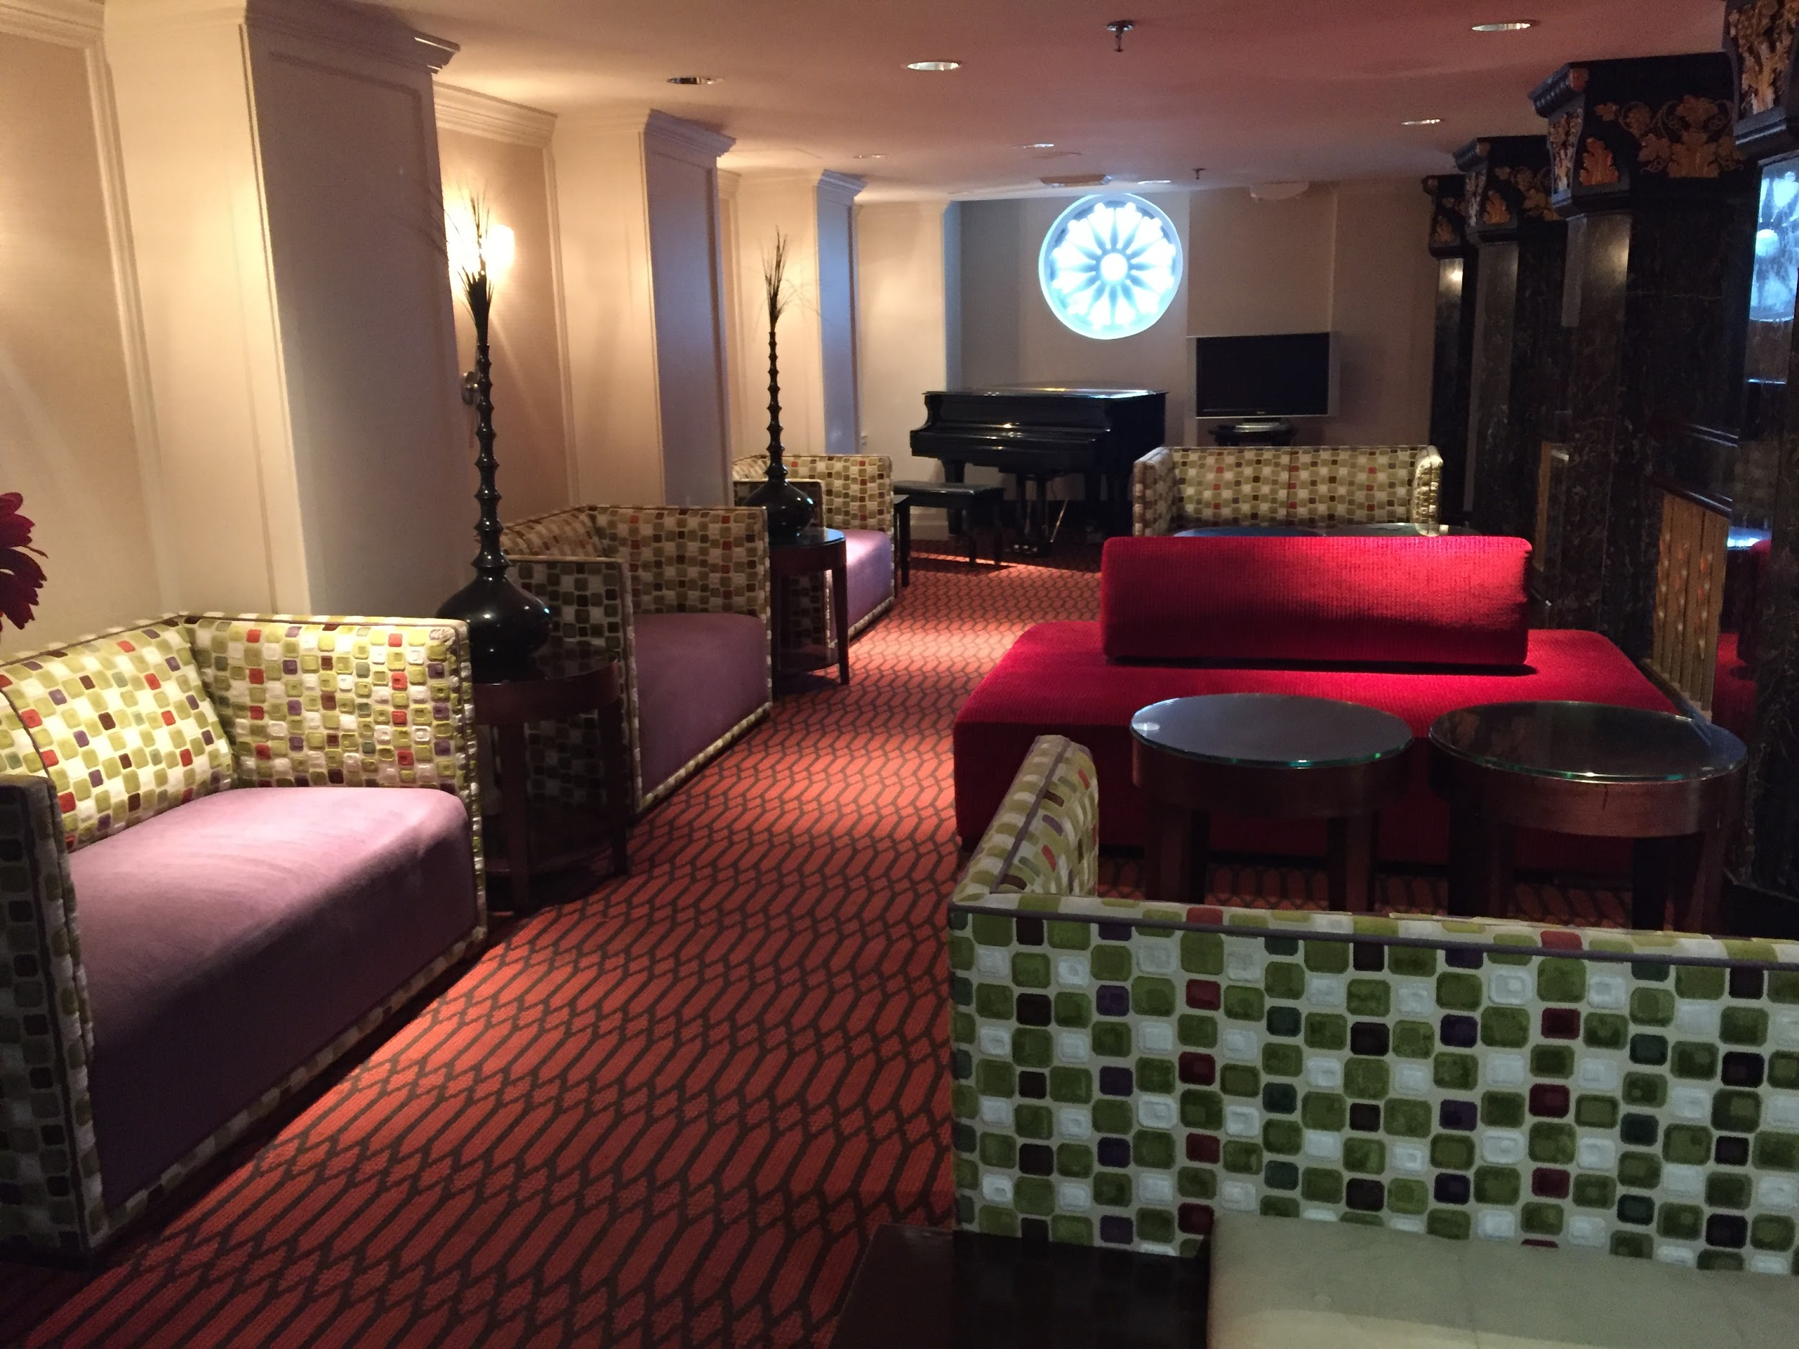
The image shows one of the general lounge areas at the Aladdin hotel. The main walkway through the lounge is somewhat narrow due to the amount of seating on either side. On the left are three loveseat style couches in a row against the wall. Each has a dark lavender bottom cushion and quilted patterned back and armrests; the checkered pattern is gray, beige, brown, white, green, and red. Between the couches are tall decorative candlestick-style accents. On the right there are three more couches, facing perpendicular to the ones against the left wall. Two of these are the same style as those against the left wall. The one in the middle is a bright red couch with a red cushion style back. Between these couches are small round tables. Against the back wall is a small piano with a light blue art-deco style decorative light above it. The floor is carpeted in a red and black diamond pattern.

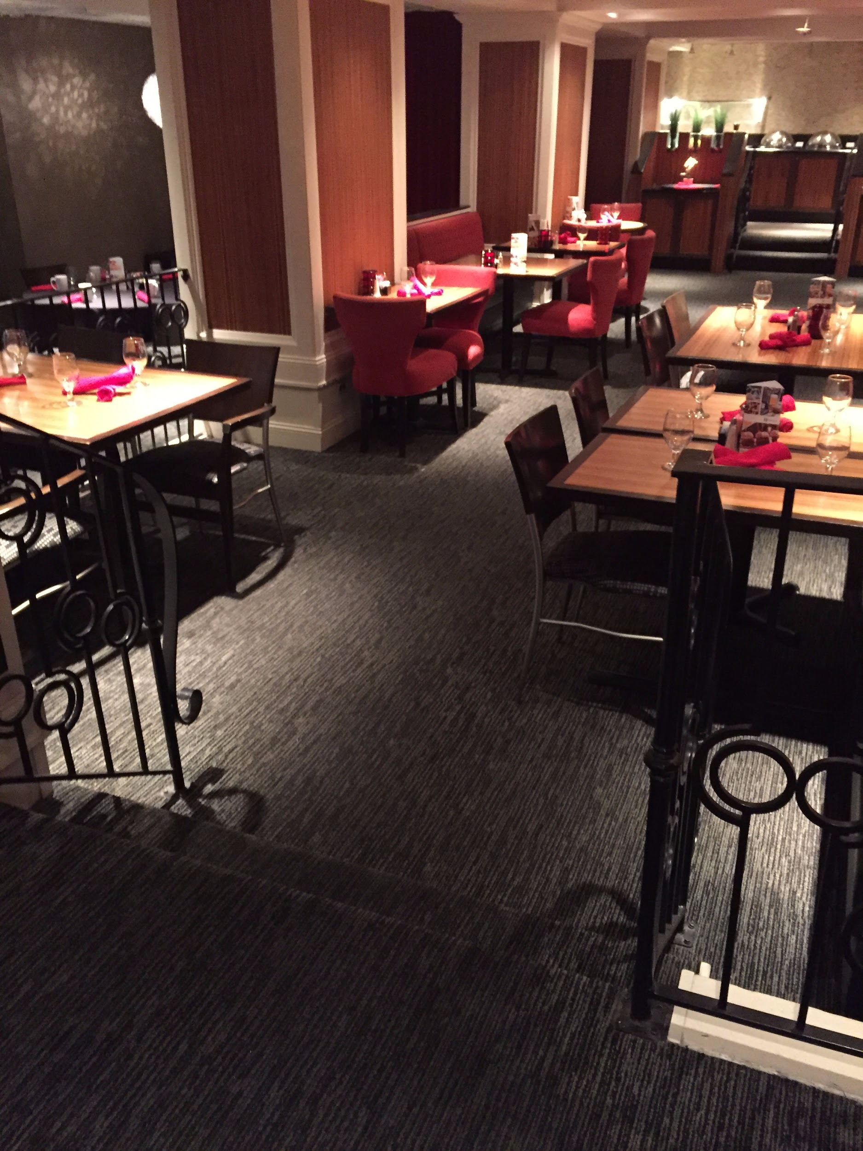
The image shows part of the dining area in the Aladdin hotel. It is dimly lit and there is a dark gray carpet throughout. In the foreground are two steps with a flimsy rod iron railing that one will have to navigate in order to access the main dining area. There are seven tables in the image, all of which are set with clear wine glasses and silverware wrapped in bright red cloth napkins. Three of the tables are four-tops and four tables are two-tops. The four-top tables have more traditional restaurant seats, but the two-top tables have bright red cushioned seats. In the background is a glimpse of the buffet area, which is on a raised platform. There are two stairs one has to climb in order to access the buffet.

Crowne Plaza, Kansas City Downtown
Note: Depending on the conference size, there may be sessions in this hotel.
19.5 miles from Kansas City International Airport
https://www.ihg.com/crowneplaza/hotels/us/en/kansas-city/mkcws/hoteldetail
They have a special tab (Special Needs) on their webpage for accessibility information: https://www.ihg.com/crowneplaza/hotels/us/en/kansas-city/mkcws/hoteldetail/accessibility#

Pros
- The standard king room has wide space in the main living area for movement and has double sliding mirrored closet doors.
- King suites have a wide door between rooms and open into a bedroom from a living room space. There is wide space for moving. The bathroom door is 28" wide and there’s a low counter inside the bathroom, a walk-in closet,and a tub/shower combination with one handrail.
- Elevators and rooms both have Braille signage.
- Carpet is generally low pile.
- The lobby is quite wide and roomy.
- The restaurant has wide space for movement and an accessible buffet.
- There’s a Starbucks in the lobby.
- There are accessible parking options (see below).

Cons
- King suites are the only accessible rooms.
- The doors from elevator to the parking garage are not automatic.
- The carpet isn’t super busy and it’s generally low pile, but it’s often striped and there are many places where a number of different patterns meet.
- There’s dim lighting in the lobby.
- The bar is a small space that’s not easy for wide movement.

Parking
- Self parking is $10.00 per car, per day for event parking and $19.00 per car, per day for overnight guests.
- Valet parking is $14.00 per car, per day for event parking and $23.00 per car, per day for overnight guests.
- Accessible self-parking, and van accessible self-parking available
- 16 wheelchair accessible parking spaces

Elevator measurements:
3 bank
Width 41 10/16 inches
Length 7ft
Height 7ft
2 bank
31 8/12
Length 83 9/12
Height 83 9/12

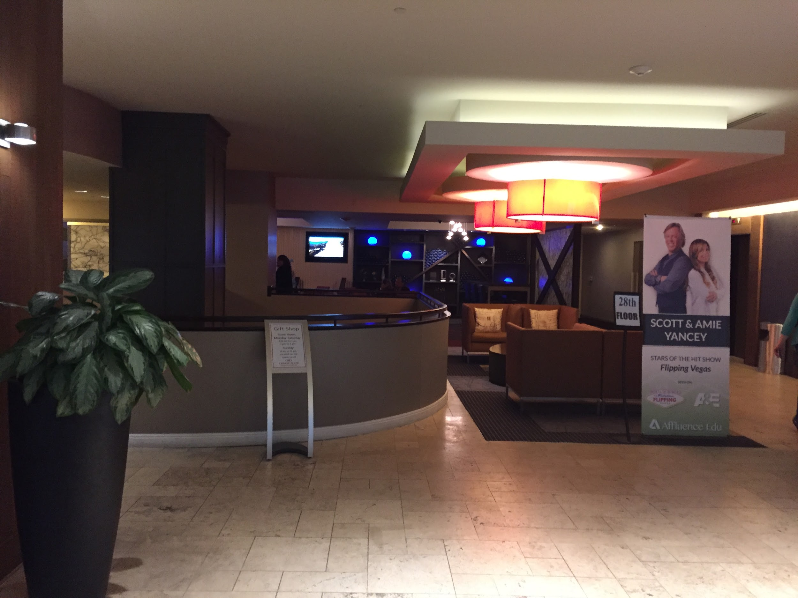
The image is of the main entryway and check-in area for the Crowne Plaza. It is spacious and decorated in neutral colors. The desk to the left is curved and in front of the desk is a waiting area with brownish-red couches for seating. There are two large round ceiling lights, and the floor is off-white marble tile. To the left is a potted plant and to the right is a large standing sign that shows a white man and a white woman standing back to back with their arms folded across their chests. Under their image the text reads “Scott & Amie Yancey. Stars of the hit show Flipping Vegas.”

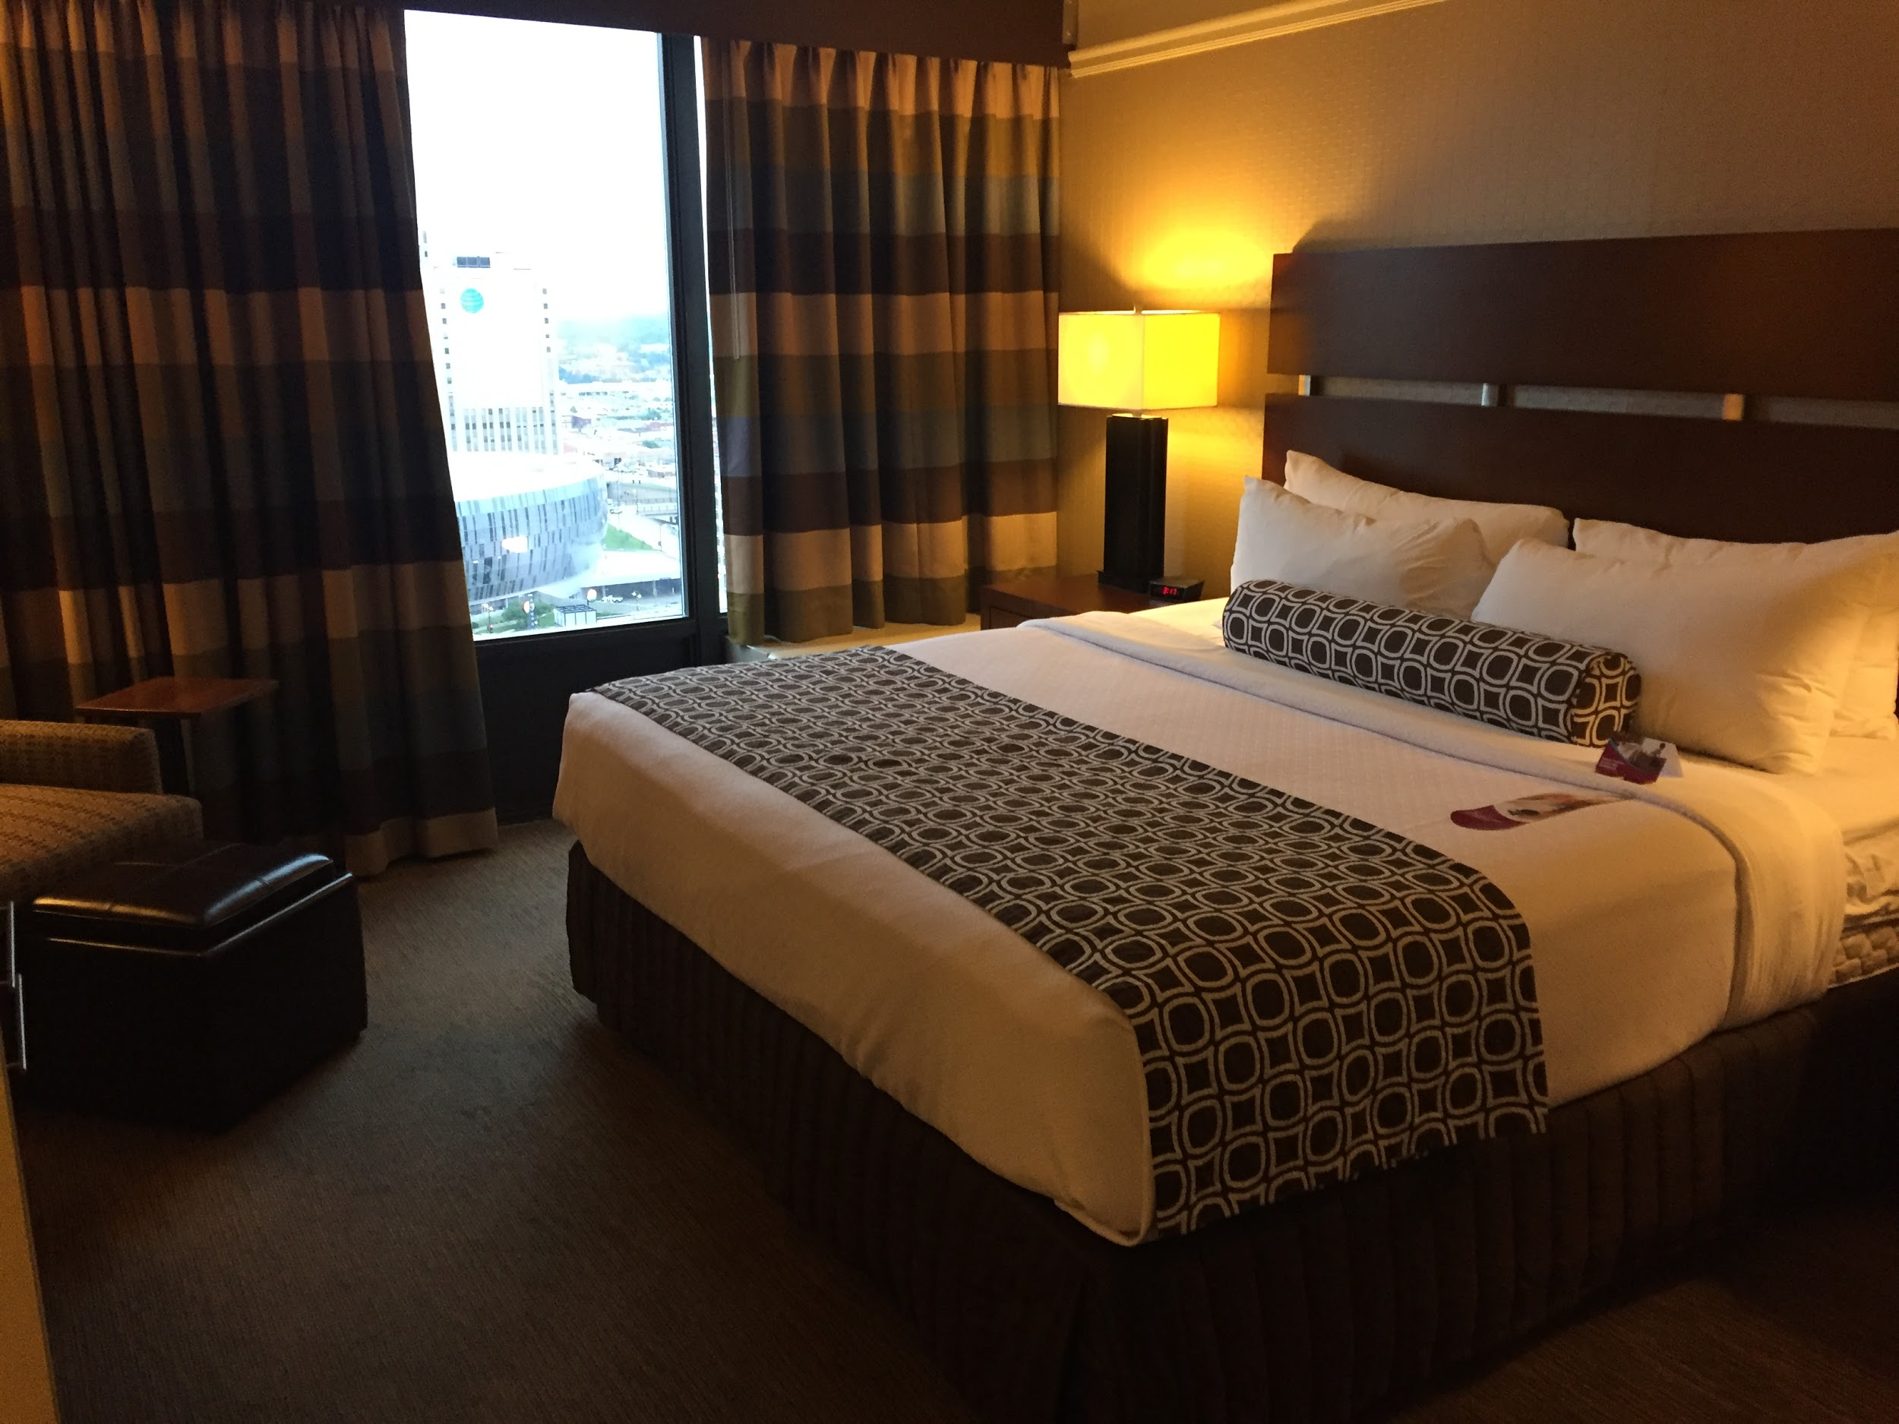
The image is of one of the rooms at the Crowne Plaza. The room is somewhat dimly lit. Near the center of the image is a king sized bed with a simple white comforter, four white pillows. There is a maroon and white square patterned blanket across the foot of the bed and a matching cylindrical bolster pillow at the head of the bed. The headboard is dark wood with silver metal accents running in a horizontal line through the middle of it. To the left of the bed is a bedside table with a (lit) lamp on it. Further to the left is a large window with curtains partially pulled back to reveal a view of the convention center. The curtains are dark with a wide horizontal striped pattern in beige, brown, smoky blue, and maroon. The carpet is dark gray. In the far left corner is a gray arm chair with a dark brown leather ottoman.
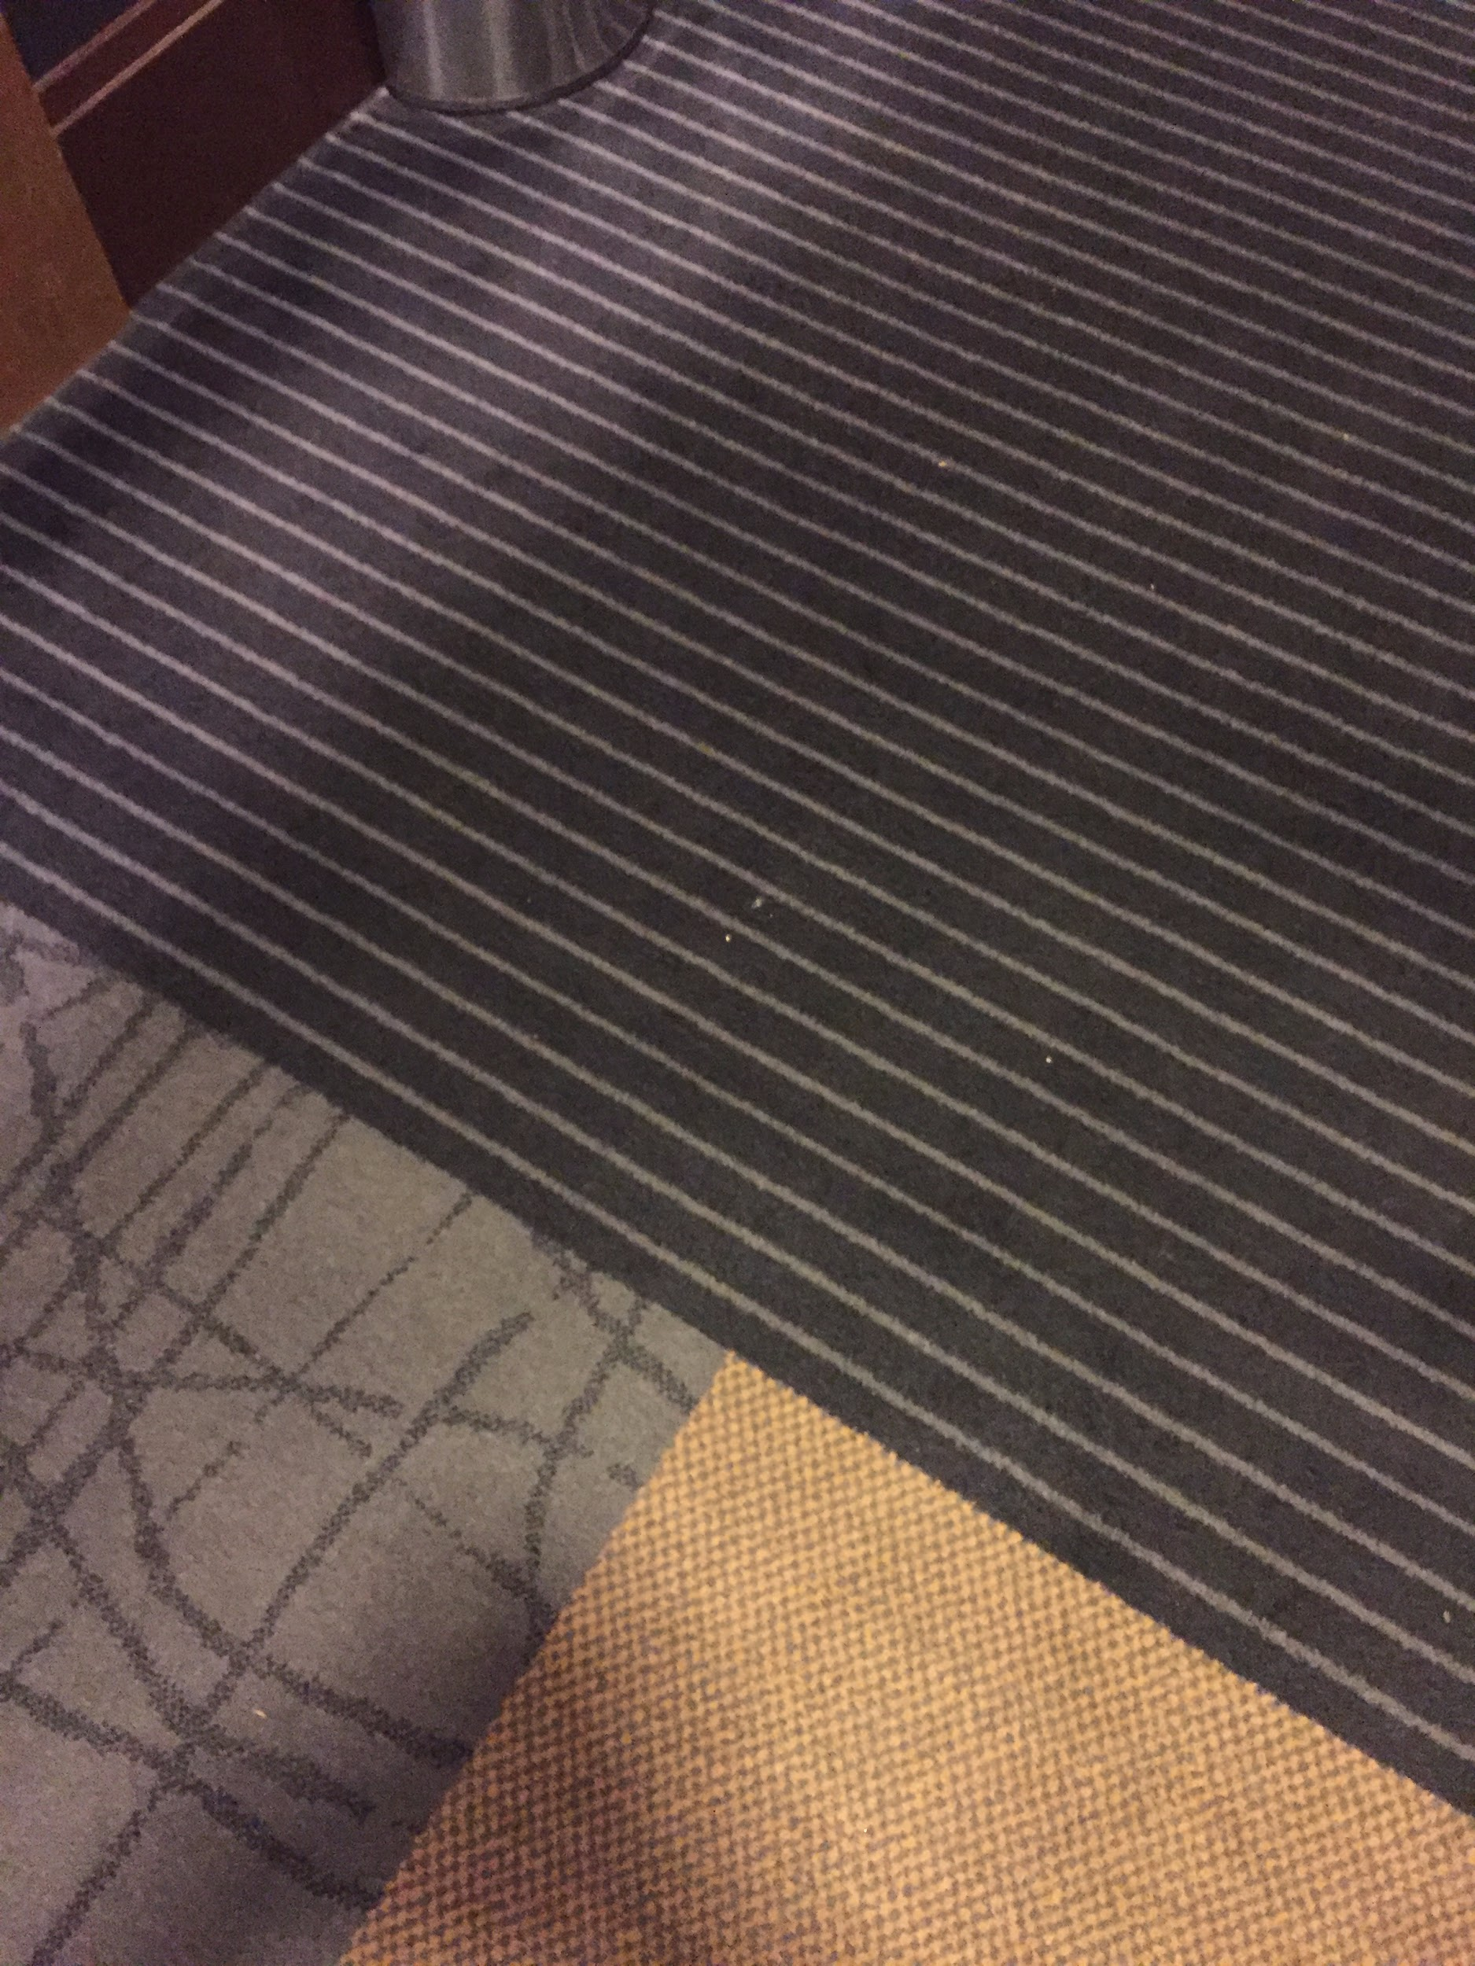
The image is of three different carpet styles, all meeting at one spot at the Crowne Plaza. In the lower left is a light gray carpet with darker gray lines running through it in a random pattern. In the lower right is a yellowy-beige mottled style carpet. The top part of the image is of black carpet with gray horizontal lines running through it. There is no flooring strip to separate the different carpets. All are low pile.

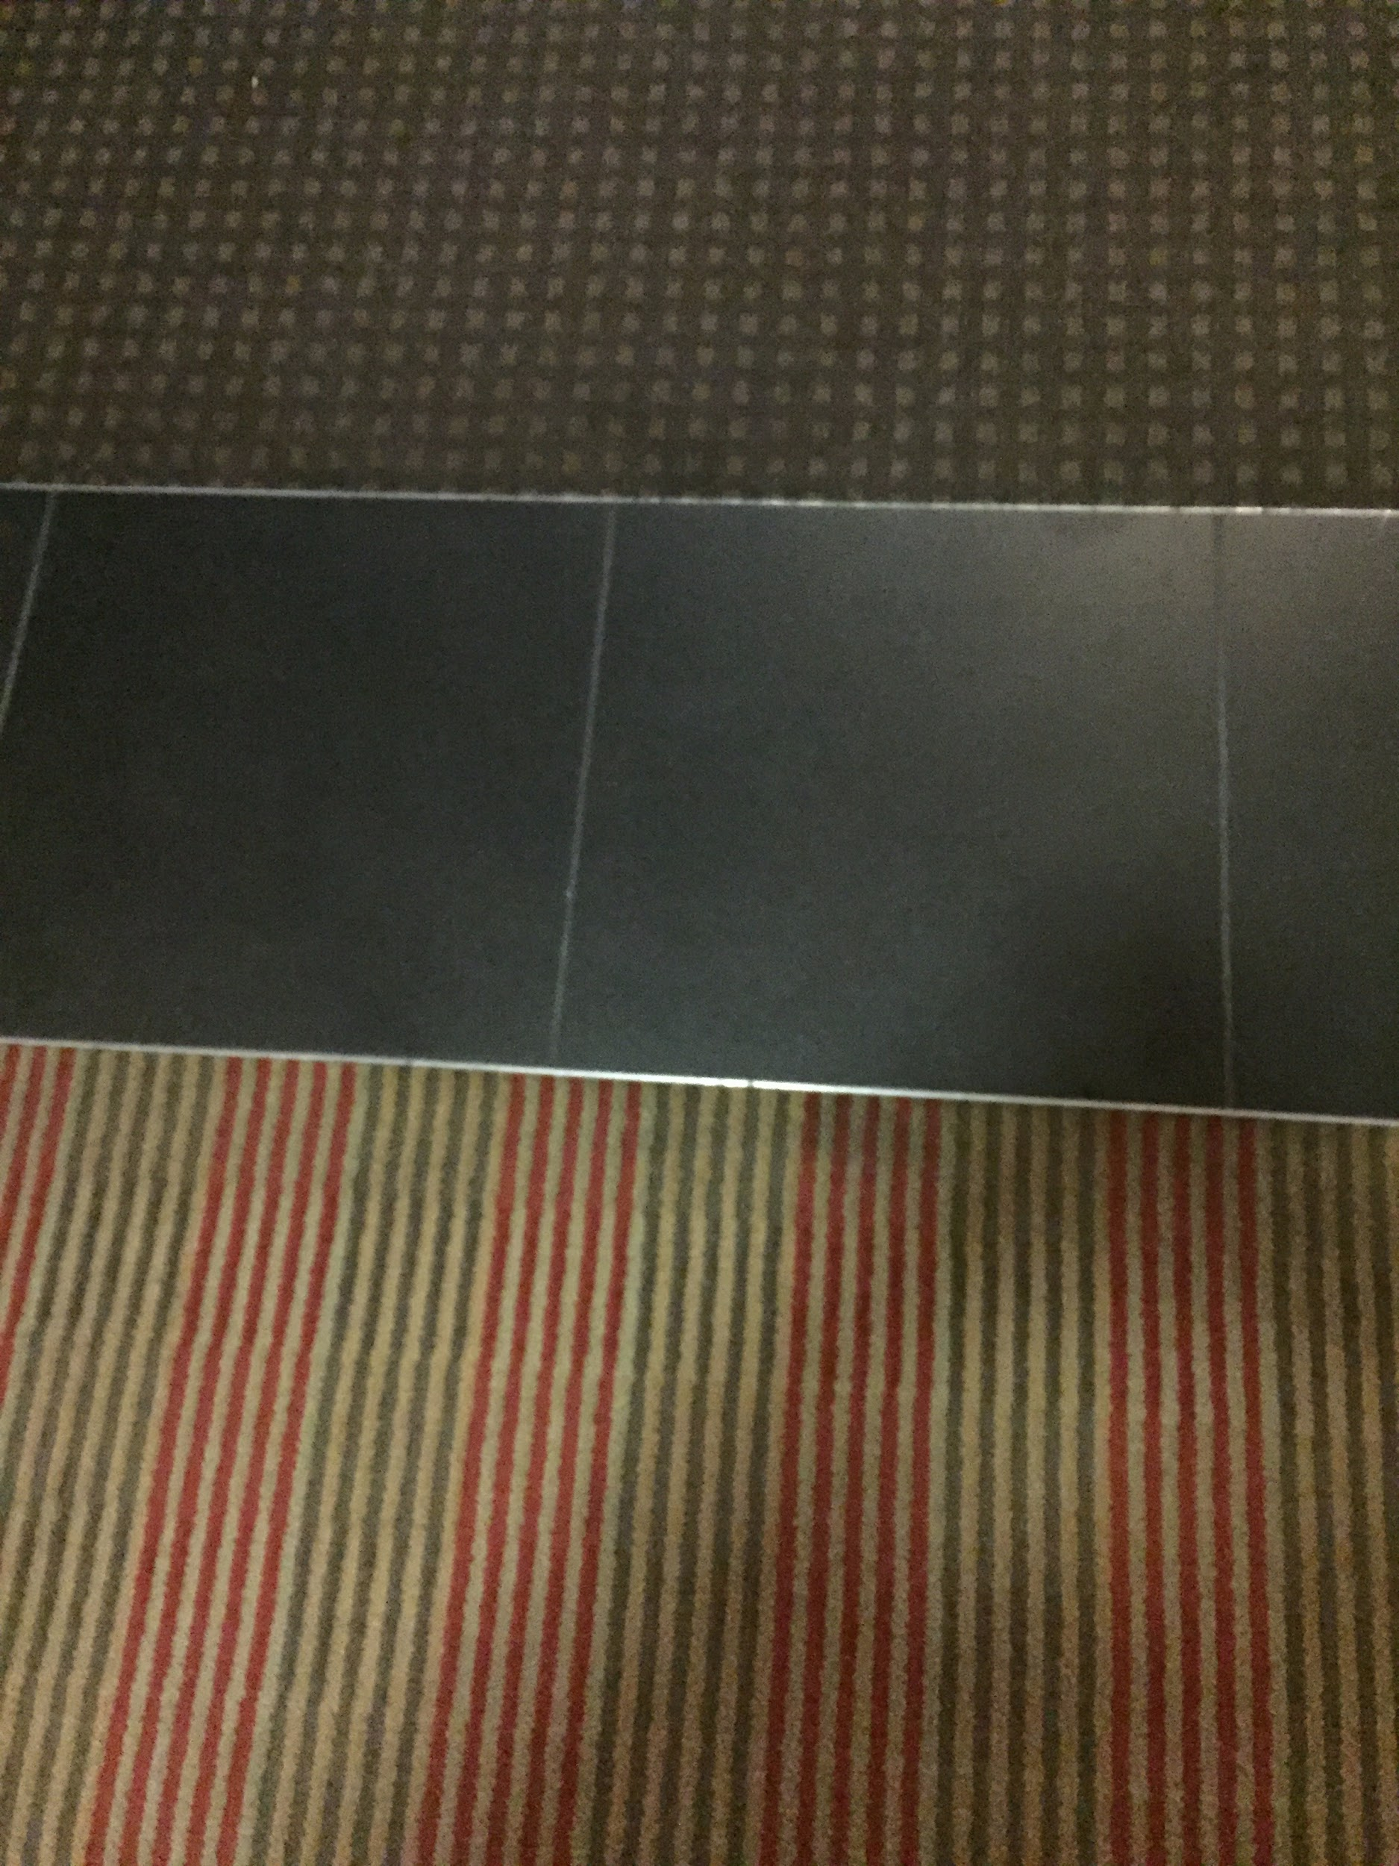
The image shows three different kinds of flooring at the Crowne Plaza. The bottom of the image shows a red, green, and beige striped carpet. The narrow stripes are in a repeating pattern: five green and beige stripes, five red and beige stripes, five green and beige stripes, etc. In the middle of the image is a strip of single dark gray tiled flooring. At the top of the image is a dark gray carpet with small beige squares in a pattern throughout. There is a silver flooring strip between the carpets and the tile.

