CCCC 2018 Accessibility Guide

Kansas City, MO

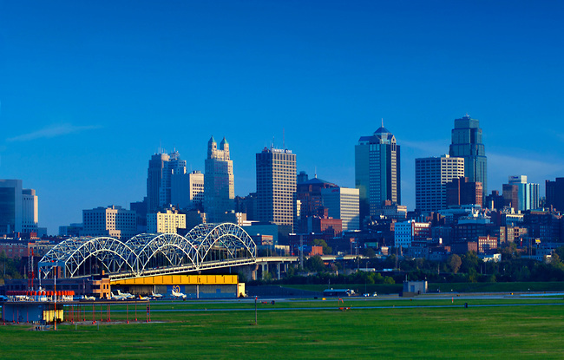
Kanas City skyline. Photo credit: Anthony John Coletti photography

Table of Contents
CCCC 2018 Accessibility Guide 1
Kansas City, MO 1
CONTACT PERSONNEL 6
AT THE CONFERENCE 9
Access Table 9
Interaction Badges 9
Sign Language Interpreters and CART 10
Quiet Room 10
Lactation Room 10
Family Room 10
Weather 11
ARRIVING IN Kansas City 12
Kansas City International Airport (Code: MCI) 12
Accessibility Services Available at Kansas City International Airport 13
TSA Help Line 13
GETTING TO YOUR HOTEL 14
Shuttle Services 14
Public Transportation 14
Taxis 15
Car Rentals 15
Wheelchair Accessible Van Rentals 15
HOTELS 15
Kansas City Marriott, Downtown 15
Crowne Plaza, Kansas City Downtown 29
Aladdin (Holiday Inn Kansas City Downtown) 31
CONFERENCE ACTIVITY 32
Technology 32
Kansas City Marriott, Downtown 33
Kansas City Convention Center 41
Nearest Drugstores 45
Local Committee Website 45
Thanks 45

Welcome!
Welcome to Kansas City! We’re so happy to host you here in the Midwest and hope you have an energizing, engaging, and fantastic conference experience.

We have attempted to address many accessibility issues and hope that attendees will find this guide useful during their trip to Kansas City for the 2018 CCCC. Of course, there may be questions or needs that have not been addressed here. Please feel free to contact us so that we may address your concerns individually.

Signed,
The Kansas City CCCC Team

CONTACT PERSONNEL
Chair of the Committee on Disability Issues in College Composition
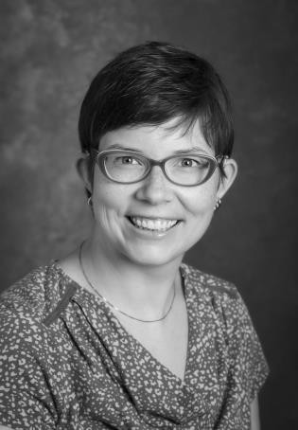
Stephanie Kerschbaum, kersch@udel.edu

Local Arrangements Chair
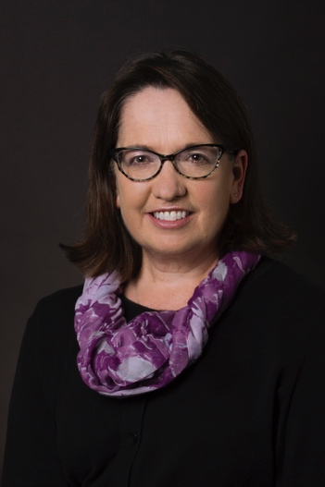
Jane Greer, greerj@umkc.edu
Local Accessibility Committee Co-Chairs
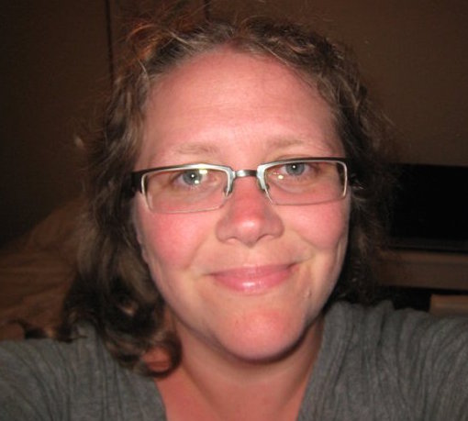
A. Abby Knoblauch, abbyk@ksu.edu

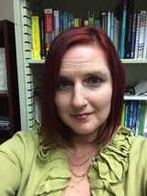
Muffy Walter, muffy.walter@washburn.edu

Sign Language Interpreters and CART
Julie Gebron, Julie.gebron@purple.us

NCTE Accessibility Requests Points of Contact
Emily Nafziger, cccc2018@ncte.org

AT THE CONFERENCE
The Committee on Disability Issues in College Composition and the local Accessibility Committee are committed to making the CCCC accessible for all attendees. If you need to request accommodations such as sign language interpreting or Computer Assisted Real Time Captioning (CART) that may require advance planning on the part of NCTE/CCCC staff, please contact Emily Nafziger at cccc2018@ncte.org. They can best meet your needs when notified prior to March 1, 2018.

While this guide focuses on many aspects of the physical locations of the conference and getting around the Kansas City, this commitment to making CCCC accessible for all attendees extends beyond that. Another dimension of access involves ensuring that presentations themselves are accessible to all conference attendees. Much more information about accessibility measures for presentations can be found at the Composing Access website, which includes a number of documents and videos with ideas for how to enhance accessibility in conference presentations. We strongly encourage all conference attendees to review these suggestions in planning presentations in all formats.

If you know of a conference presenter who is not aware of the Composing Access Website please share the site with them so that more CCCC presentations are accessible for all attendees.

Access Table
The CCCC Access table will be located on the second floor of the Marriott hotel next to registration in the Basie Ballroom Foyer. Volunteers will be available during regular conference hours to offer assistance with mobility and other access issues, including but not limited to helping to solve problems with space, sound, scent, or lighting; helping conference attendees navigate from session to session; and connecting attendees to resources.

Interaction Badges
Interaction or communication badges will be available at this table. These badges offer a colored-card system for indicating how you prefer to socialize. Interaction badges are red/pink, yellow, green, and blue slips of paper that can be slid into CCCC plastic name badge holders. Of course, it’s best not to assume that every person you encounter is able to see or notice your badge. Use a variety of cues for interaction when possible.
- Red/pink: please do not initiate interaction with the person.
- Yellow: one should initiate interaction only if given prior permission to do so.
- Green: the person would like to socialize but has difficulty initiating and would like others to initiate communication.
- Blue: the person will initiate their own interaction. While blue is the suggested color for “I will regulate my own interaction,” it is not necessary to use any badge at all.

Sign Language Interpreters and CART
Sign Language Interpreters and CART services will be provided by Purple Communications and coordinated on-site by Julie Gebron, M.Ed, RID CI/CT, NAD IV. Julie is a former teacher and an experienced professional ASL interpreter dedicated to the provision of excellent communication access for conference participants. She previously coordinated services for CCCC and NCTE in 2017, and can be reached for specific interpreter and CART needs at julie.gebron@purple.us. To learn more about sign language interpreters, please see the RID (Registry of Interpreters for the Deaf, Inc.) website. For information about CART, please see the “Communication Access Realtime Translation” page of the National Association of the Deaf website.

Quiet Room
The Quiet Room will be located in the Taft Room on the Main Level Lobby of the Muehlebach Tower of the Marriott. The quiet room is intended to provide a quiet, calm space where attendees can spend time away from the noise, lights, and other stimuli of conference spaces. The quiet room is not available for conversations or meetings. The Quiet Room hours are Wednesday through Friday: 7:00 a.m.–9:00 p.m. and Saturday: 7:00 a.m.–5:00 p.m.

For personal use on your earphones, ambient sound and other noise canceling can be found through MyNoise.net (free and available via web browser and app) and SleepPillow (free trial version).

Lactation Room
There will be two lactation rooms. One of the locations will be in the Marriott; however, this will be a hotel room and attendees will need to ask for a key at the Registration Desk. They should simply say they are attending the conference and would like to use the lactation room. A second lactation room is at the Convention Center Room 2503.

Family Room
The Family Room is at the Marriott Hotel in the Kennedy Room. This room is for CCCC participants who bring children with them to the conference, but there are no childcare providers available in this room. There will be room for children to bring their own activities.
Books, writing materials, and other materials will be provided. Children must be accompanied by a parent or guardian.

Weather
In March, the high temperature tends to be in the mid-to-high 50s. Nights tend to drop into the mid-to-low 30s or 40s. Spring storms are unpredictable in Missouri, so we’d recommend packing a travel umbrella or light raincoat. Weather predictions tend to shift quickly in the spring months. Sweaters or very light jackets will be good for inside the conference areas and late evenings since temperatures may vary.

ARRIVING IN Kansas City
Kansas City has one major airport: Kansas City International Airport (MCI). Note: It’s helpful to know that while the airport is often abbreviated as KCI, the IATA (International Air Transport Association) code is MCI.

For information about the airport, please go to the Kansas City International Airport website.

The airport is about a 20-minute drive from the conference site. More specific information about average travel time between the airport and the conference hotels is included with hotel information.

The conference hotels do not have shuttles to or from the airport, but SuperShuttle services all three conference hotels. There is also a Metro bus service, as well as Uber services and taxis. You’ll find more about transportation options below.

Kansas City International Airport (Code: MCI)
Kanas City, MO 64153

Directions Using Google Maps can be found at www.google.com/maps/place/Kansas+City+International+Airport

Airport Information: 816-243-5237
Airport Police for emergency issues: 816-243-4000
Airport Police for non-emergency issues: 816-243-5237

It’s useful to note that while the official airport code is MCI, Kansas City International Airport is also often referred to as KCI.

Kansas City International Airport is made up of three distinct terminals: Terminal map of Kansas City International Airport.

The RED BUS provides complimentary transportation among all three terminals. Bus stops are located outside each terminal building and are designated by overhead signs marked “Red Inter-Terminal Connection.

Accessibility Services Available at Kansas City International Airport
The airport’s Special Traveler Services page provides information about accessibility services.

Wheelchair Assistance
Wheelchair reservations and curbside assistance can be arranged by calling your airline. You can go to the Special Traveler Services page for more information or contact a specific airline (airline phone numbers). If no assistance is available at the curb, notify an Airport Police Officer of Traffic Control Officer. Or you can call 816-243-5237.

Elevators
All high-traffic areas of the airport are wheelchair-accessible by elevators, including ticketing and baggage claim. Elevators are located near each escalator.

All public restrooms and family restrooms are wheelchair accessible.

Rest and relief areas for service animals are located at each end of each terminal in grassy areas adjacent to pedestrian ramps. They are marked with instructional signs and include special waste receptacles and biodegradable bags.

TTY is located throughout all terminals at pay phone locations.

Visual paging monitors are located throughout the terminals. The monitors provide taxi and security alert information, and public announcements are displayed by request.

Braille signage exists in most public areas.

TSA Help Line
TSA has a TSA Help Line to assist travelers planning to fly on any airline in the United States. TSA Cares is a help line to assist travelers with disabilities and medical conditions. TSA recommends that passengers call 72 hours ahead of travel for information about what to expect during screening. Travelers may call TSA Cares toll free at 1-855-787-2227 prior to traveling with questions about screening policies, procedures and what to expect at the security checkpoint. TSA Cares will serve as an additional, dedicated resource specifically for passengers with disabilities, medical conditions or other circumstances or their loved ones who want to prepare for the screening process prior to flying.

Travelers may also request a Passenger Support Specialist ahead of time by calling the TSA Cares hotline at 1-855-787-2227. The hours of operation for the TSA Cares Help Line are Monday through Friday 8 a.m. –11 p.m. ET and weekends and holidays 9 a.m.– 8 p.m. ET. Travelers who are deaf or hard of hearing can use a relay service to contact TSA Cares or can e-mail TSA-ContactCenter@tsa.dhs.gov. When a passenger with a disability or medical condition calls TSA Cares, a representative will provide assistance, either with information about screening that is relevant to the passenger’s specific disability or medical condition, or the passenger may be referred to disability experts at TSA.

GETTING TO YOUR HOTEL
Multiple options for ground transportation are available.

Shuttle Services
Kansas City Aviation Department lists fourteen services that can be found on the Shuttle Services page of the KCI website. Some of these are through reservation only and others have scheduled shuttle service.

Public Transportation
RideKC is the Kansas City public transportation bus service. Busses operate to and from KCI every day of the week. RideKC buses accept cash and 31-Day Bus Passes. The regular fare one-way to or from KCI is $1.50. Reduced fare for eligible seniors, youths and persons with disabilities with a reduced farecard or Medicare card is $0.75.

Fareboxes accept exact change only; if you do not have exact change the driver can issue a change card that holds a credit. Inform the driver before inserting money into the farebox if you want a change card.

For routes, schedules and additional information please visit their website or contact RideKC directly at 816-221-0660.

Taxis
Courtesy phones for taxi service are located both inside and outside terminals at each bag claim area and at other strategic locations outside the terminal exits. You should give the dispatcher your exact location. If calling from a personal phone, call 816-243-2345. Rates are $2.50 plus $2.10 per mile. Rates may vary due to traffic delays and waiting time. Fares may be pro-rated (shared) when the originating passenger requests it and all other passengers agree.

Car Rentals
All rental car companies share a Gray Rental Car Shuttle that stops at marked shelters at terminal medians. You can find more information at the Rental Car page of the KCI website.

Wheelchair Accessible Van Rentals
Accessible Vans works with a network of wheelchair van rental companies. You should schedule your rental in advance of arriving in Kansas City. You can do so at the Accessible Vans of America LLC website. You can call at 314-888-9450.

HOTELS
There are three conference hotels: Kansas City Marriott, Downtown; Crowne Plaza, Kansas City Downtown; and the Aladdin Hotel (Holiday Inn, Kansas City Downtown). Most conference events will be held in the Kansas City Marriott, Downtown; some may also be held at Crowne Plaza.
There are two parts/towers to Kansas City Marriott, Downtown: the Marriott Main Tower (also often just referred to as The Marriott) and the Muehlebach Tower. Information about both is included below.

Primary Conference Hotel:

Kansas City Marriott, Downtown
200 West 12th St.
Kansas City, MO 64015
(816) 421-6800

The Kansas City Marriott, Downtown is 19.1 miles from Kansas City International Airport (MCI). It is 0.2 miles from The Kansas City Convention Center (about a-2 minute drive or 3 minute walk); 0.2 miles from Crowne Plaza, and 413 feet from the Aladdin Hotel.

Overall Accessibility
The hotel’s basic accessibility information can be found at the “Hotel Details” page and then scrolling down to “Accessibility.” Frankly, though, there’s not much information listed.

The Kansas City Marriott, Downtown is ADA compliant, including Braille signage, TDD capability and TDY kits for non-accessible rooms. The entrance to the hotel has a wide automatic door and there is an underground walkway leading to other hotels and the conference center. Service animals are welcome.

All rooms have mini-fridges. Unfortunately, there are no microwaves in the rooms, nor can one be brought to a room. There is, however, a microwave in the main lobby that guests can use.

However, there are some accessibility issues with the elevators. While the elevators in the main tower are quite large and there are many staff members to assist with elevator use, they are operated by touch screens from the outside of the elevators only. Once you’re in an elevator, you cannot change the floor you’re going to. Instead, you have to get out of the elevator and select a new floor from the hallway outside of the elevator. The touch screens “speak,” but the hallway outside of the elevators on the main floor is quite loud, so they’re difficult to hear. Additionally, one has to select the floor, then wait to be directed to the elevator that will go to that floor (which is not necessarily the elevator near the touch screen that one used). This could be an issue for those with mobility, vision, or hearing issues. Even more problematic is that several elevators in the Muehlebach Tower area of the hotel require employee operation.

Additionally, the entire hotel, especially the common area, seems to be, somehow, scented. When we toured the hotel, the scent was rather strong, and somewhat citric (grapefruit?).

While the carpet throughout the hotel is generally low pile, the pattern is quite busy (photos below), the pattern changes quite often, and the flooring sometimes shifts from carpet to tile.

We hope the images throughout this guide are helpful, but you can find more by clicking on the Photos Tab of the hotel’s website.

Parking and Transportation
There is no hotel-specific shuttle from the airport, but SuperShuttle services this hotel. The fee is $18 each way. There is on-site parking for $3 per hour or $18 per day. Valet parking is also available for $25 a day.

The main entrance to the Marriott has a large sliding automatic door. Valet parking drop-off is immediately in front of the main doors.

Common Areas
The lobby area of the hotel (also known as The Great Room) is primarily hard wood (or perhaps wood-style laminate?) with large area rugs. The floor area immediately in front of the check in desk is covered in medium-sized rectangular tiles. There are a number of sets of low tables, chairs, and couches in the main lobby area. The entryway has high ceilings but can be a bit loud and echo-y when busy. Complimentary wifi is available in common areas.

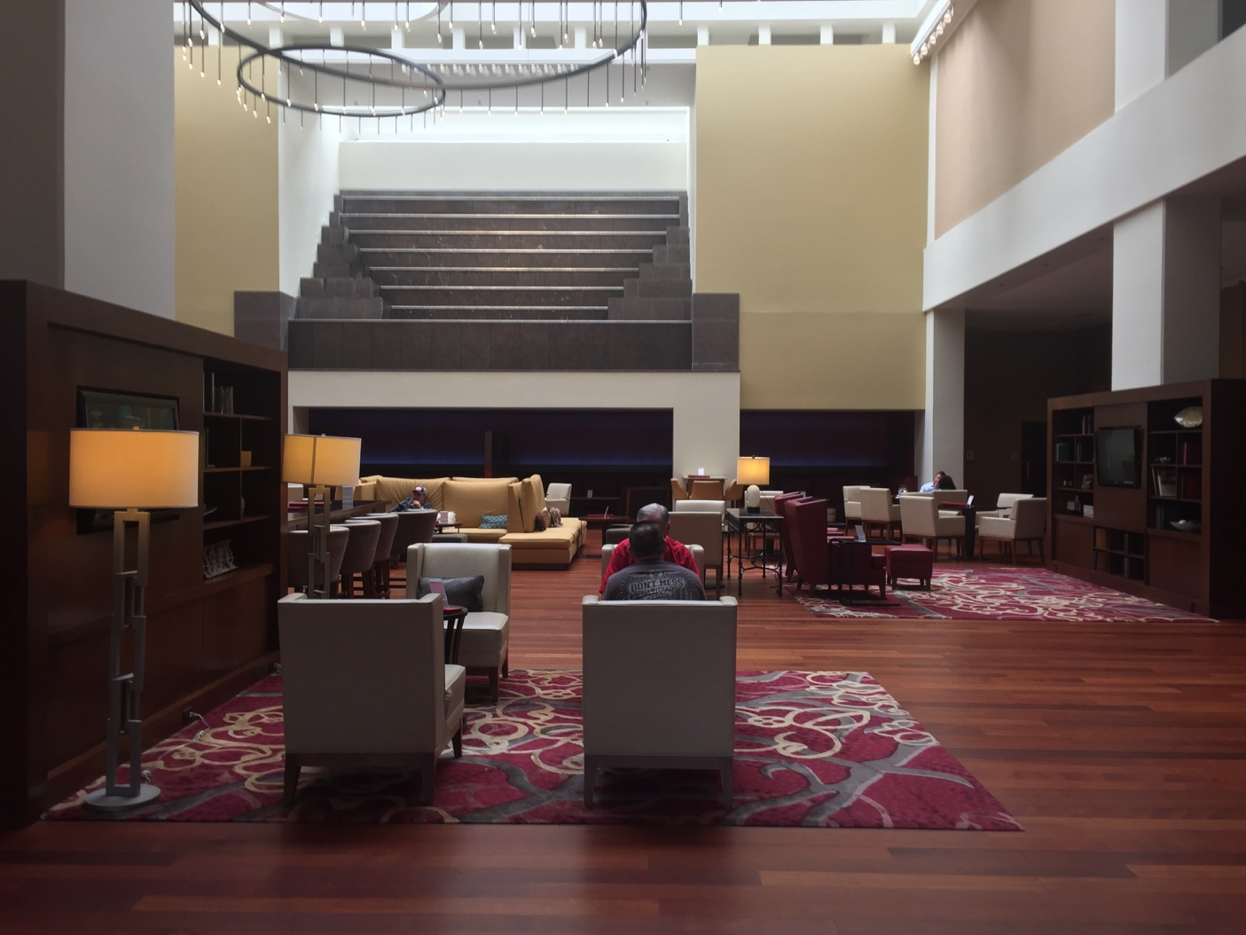
Entryway to the Kansas City Marriott, Downtown
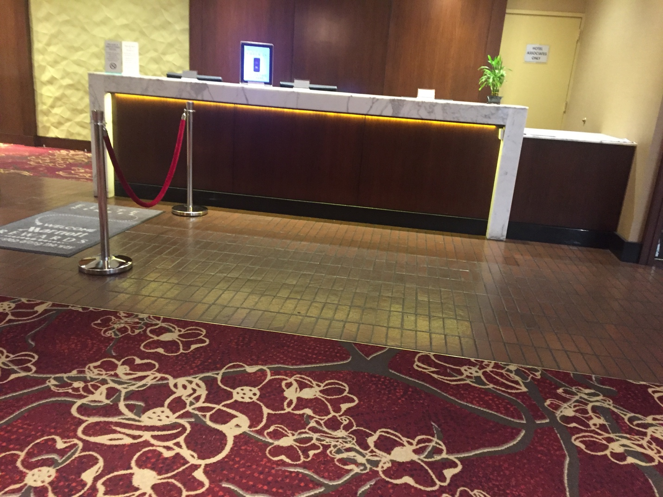
Main check-in area of the Kansas City Marriott, Downtown

There’s a bar in the lobby/Great Room (named Barcentral) which serves alcohol as well as coffee. The bar itself is about 4 feet high. There are bar chairs around it and quite a bit of room between the bar chairs and the lower chairs and tables in the common area.

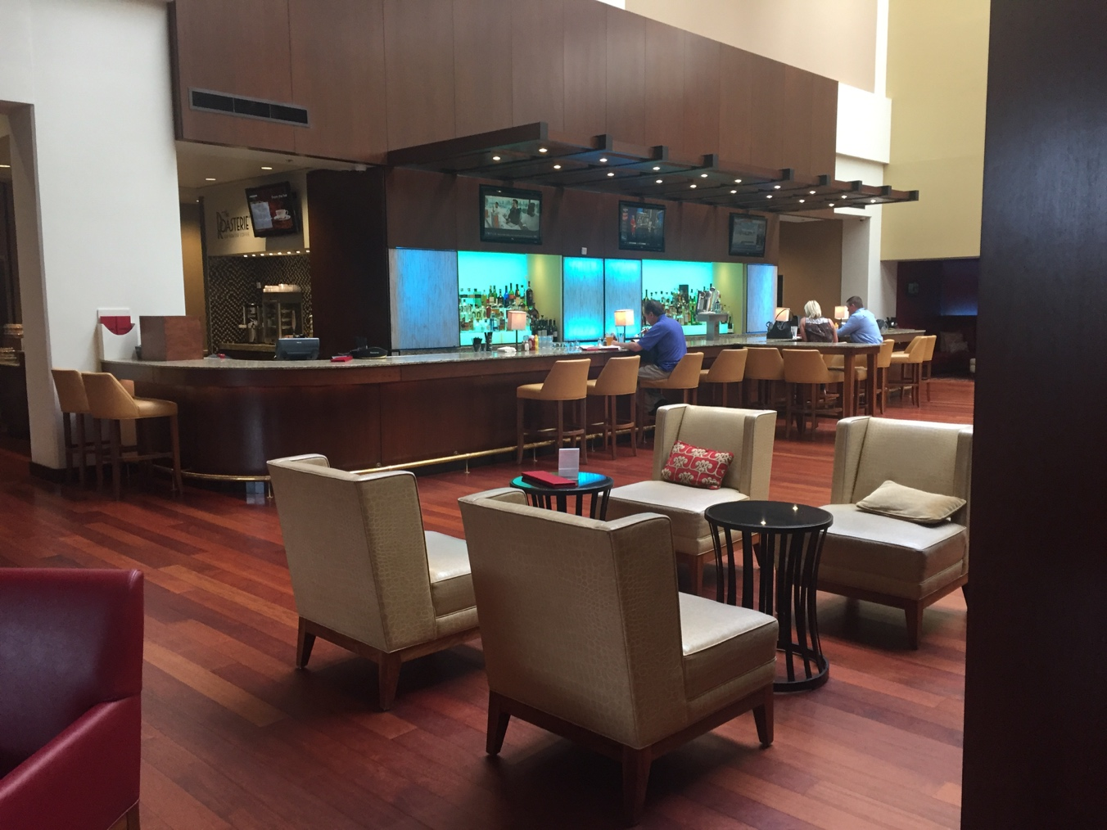
A bar (Barcentral) in the KC Marriott Downtown hotel lobby

Elevators
The main hotel elevators pose some potential accessibility issues. While the elevators are large, they are operated by touch screens from the outside of the elevators only (see the image below). Once you’re in an elevator, you cannot change the floor you’re going to. Instead, you have to get out of the elevator and select a new floor from the hallway outside of the elevator. The touch screens “speak,” but the hallway outside of the elevators is quite loud, so they’re difficult to hear. One has to select the floor, then wait to be directed to the elevator that will go to that floor (which is not necessarily the elevator near the touch screen that one used). This could be an issue for those with mobility, vision, or hearing issues.

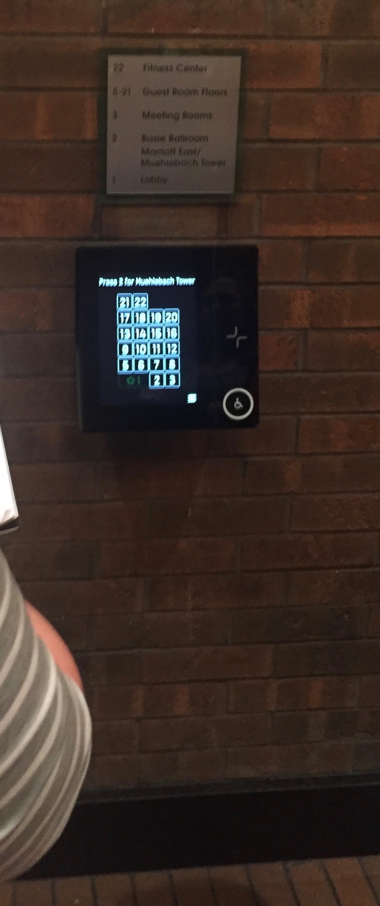
Hotel elevator touchscreen

Family & companion restrooms
The hotel has one family/companion restroom. It’s located on the 3rd floor of the Marriott tower of the hotel.

Gender Neutral Bathrooms
Gender neutral bathrooms are located at
- The Basie Ballroom Foyer across from Registration in the Marriott Tower
- The Third Level Meeting Rooms in the Marriott Tower next to Jay McShann B
- The Main Level Lobby in Muehlebach Tower across from the Colonial Ballroom
- The Trianon Level in the Muehleback Tower across from Trianon A

Exercise facilities and pool
The exercise facilities and pool technically have accessible entrances, but the doorway to the exercise room is a bit narrow. The changing/locker room is quite roomy, but the smaller lockers are set back into the wall and there’s a built in bench in front of them, making them difficult to access if one is in a wheelchair. However, there are two wheelchair accessible lockers. The locker room is carpeted throughout with a low pile brown and black patterned carpet.

The exercise facility includes treadmills, exercise bikes, elliptical machines, standard and recumbent stationary bicycles, free weights, and Nautilus-style weight machines.

The indoor 3-lane lap pool is open Monday-Friday 5:30 a.m. to 9:00 p.m. On Saturday and Sunday, it’s open 7:00 a.m. to 9:00 p.m. There is one lift for the pool.

You can find a useful 360-degree view of the exercise facility and pool on the Marriott’s photos page.

Hotel restaurant and bars
The Kansas City Marriott Downtown has in in-house casual American restaurant named MetropolitanKC, which serves a full lunch and dinner menu, as well as a breakfast buffet. The menu is seasonal, but includes vegetarian and “gluten-friendly” options. The hotel also offers in-room dining, which can also be packaged to-go.

Barcentral (in the lobby area) also serves small bites, salads, sandwiches and burgers, and dessert items for lunch and dinner (open at 11:00 a.m.). There aren’t many vegetarian options, but a number of menu items can be made “gluten-friendly.” Coffee is served from 6:00 a.m. to 10:00 p.m.

Rooms
We should note that the Marriott was in the midst of a major room renovation when we toured the facilities. The renovated rooms included in-room refrigerators. Some rooms will be updated, while others will not. Guests should contact the hotel directly with specific questions.

The Marriott has 26 total accessible rooms: 15 accessible rooms have king sized beds with tubs/grab bars, 6 of them have king sized beds with roll-in showers, and 5 of them have double beds with roll in showers.

The accessible rooms above with roll-in showers have separate strobe lights to indicate telephone calls and emergencies. Some of the king rooms will also have this feature, but not all of them will. Guests should contact the hotel to request a room with the separate strobe feature.

The hotel does not have specifically allergy-free floors. They do, however, have feather-free floors and guests should request a feather-free floor, if necessary, when booking. The hotel manager assured us that the hotel will do its best to accommodate any scent-free cleaning requests. Additionally, the hotel does not have washers/dryers on premises. All guest laundry is sent off-property to our local service.
TDD capability and TDY kits are available for non-accessible rooms. All room numbers have Braille signage. Carpets in the hallways are generally low pile and somewhat spongy, but rather busy (image below).
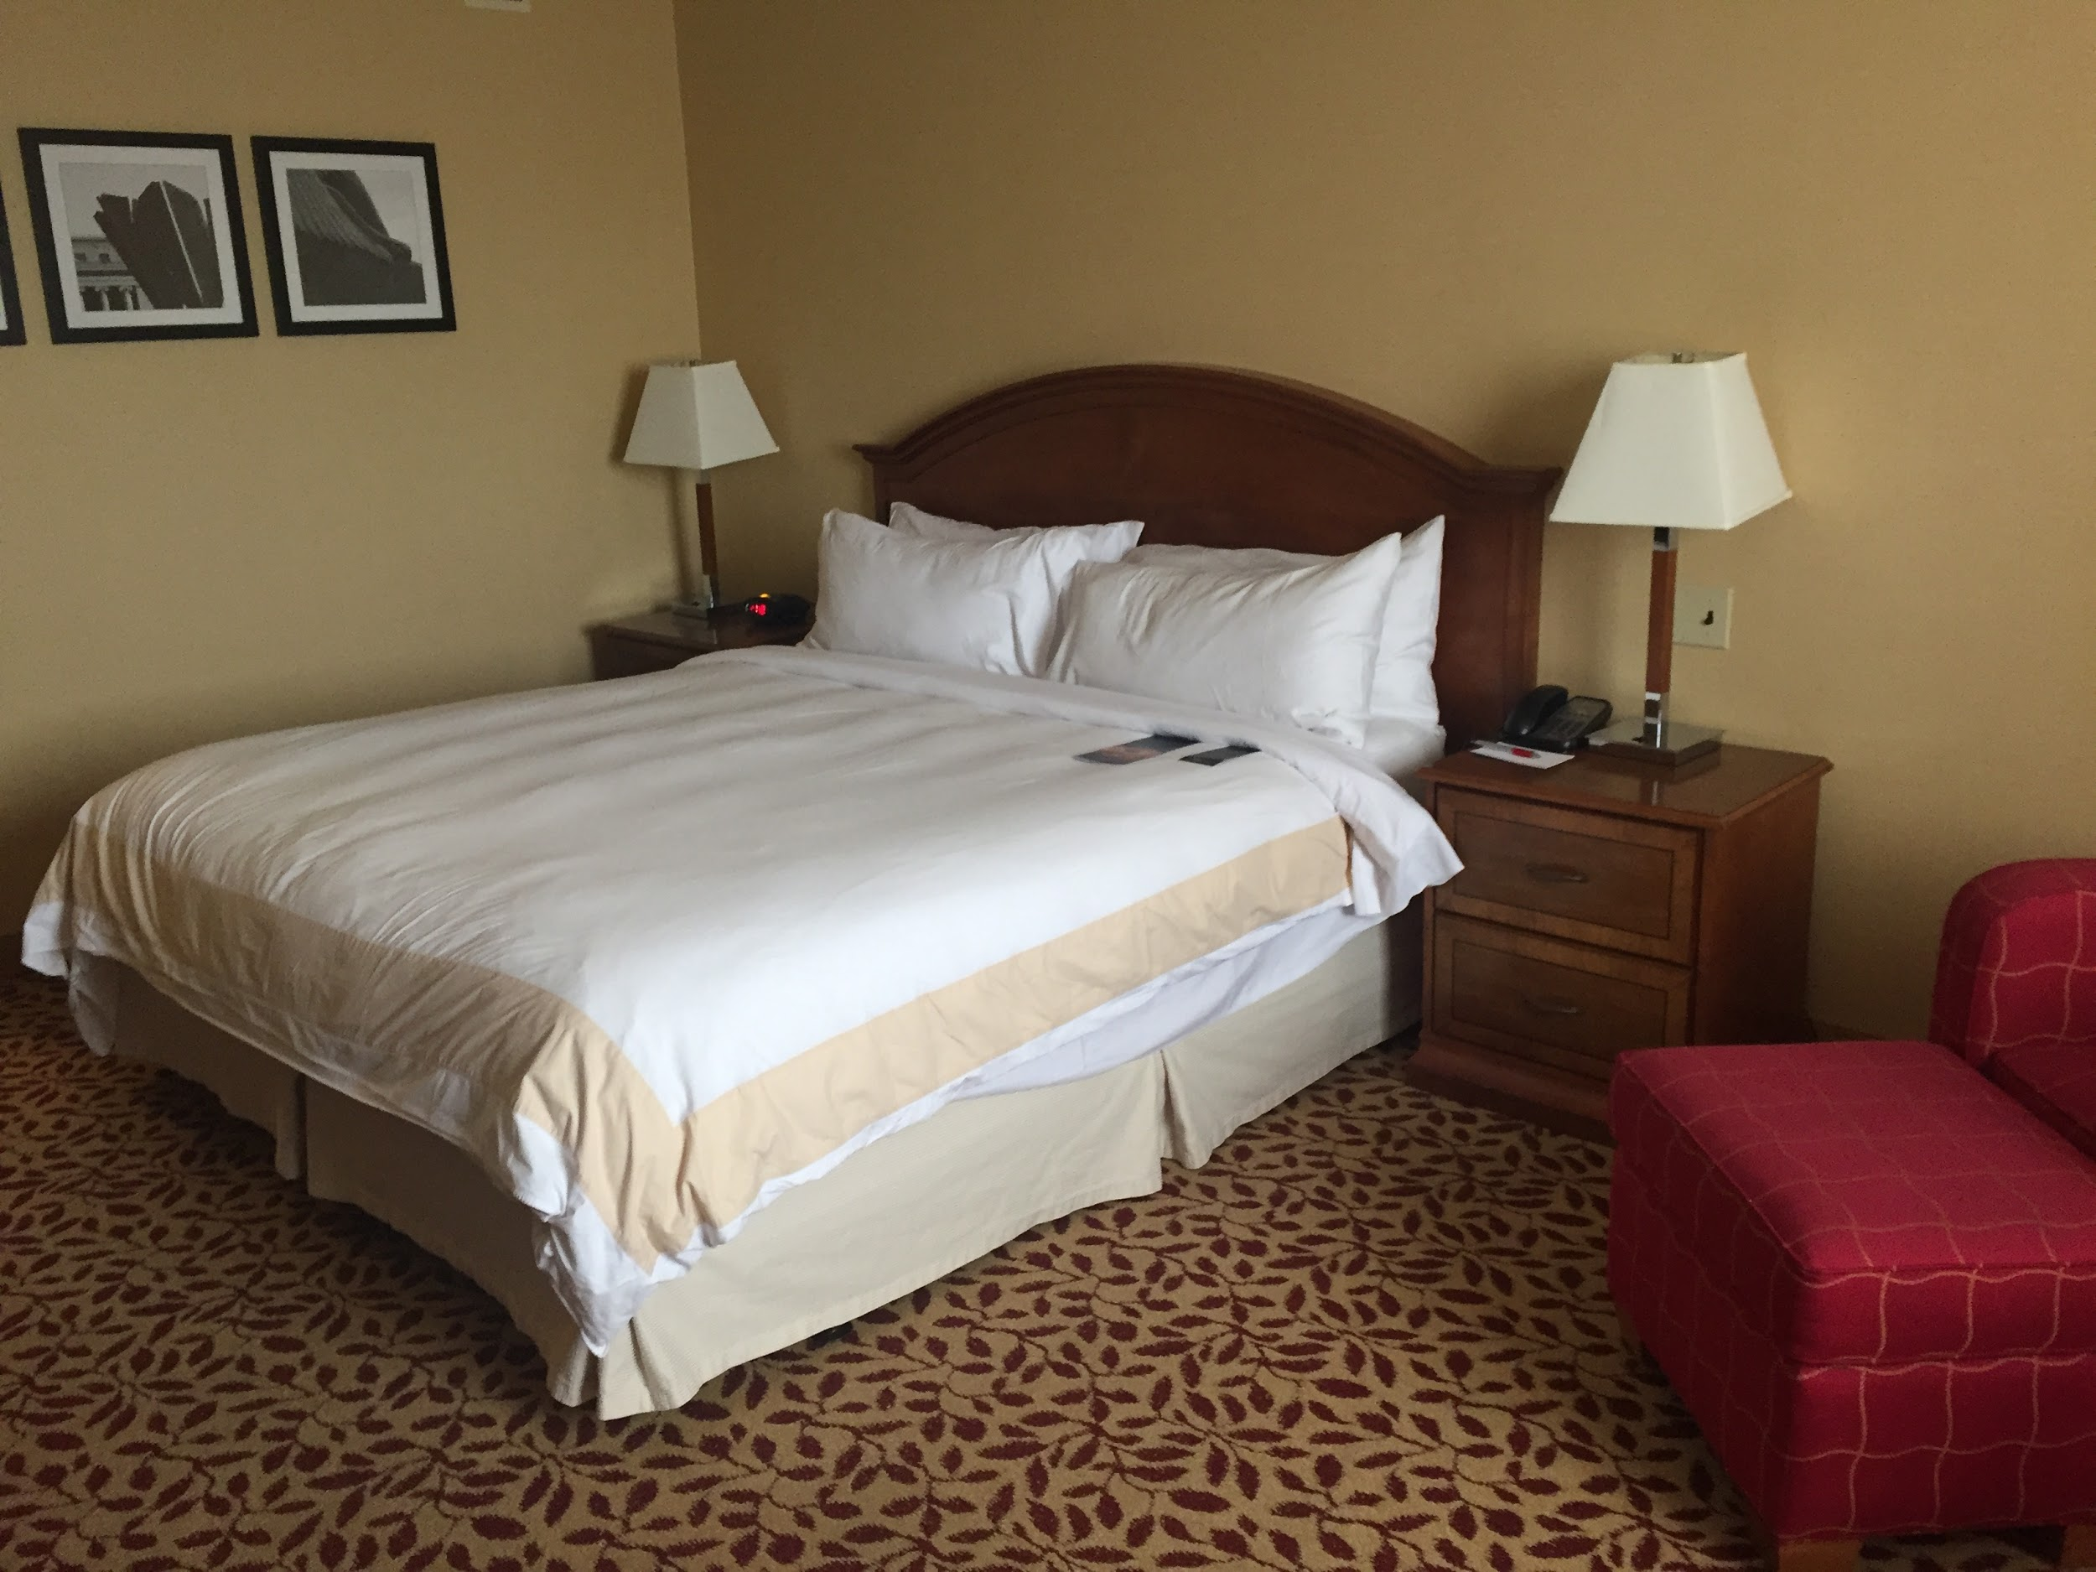
Main sleeping area of Marriot hotel room

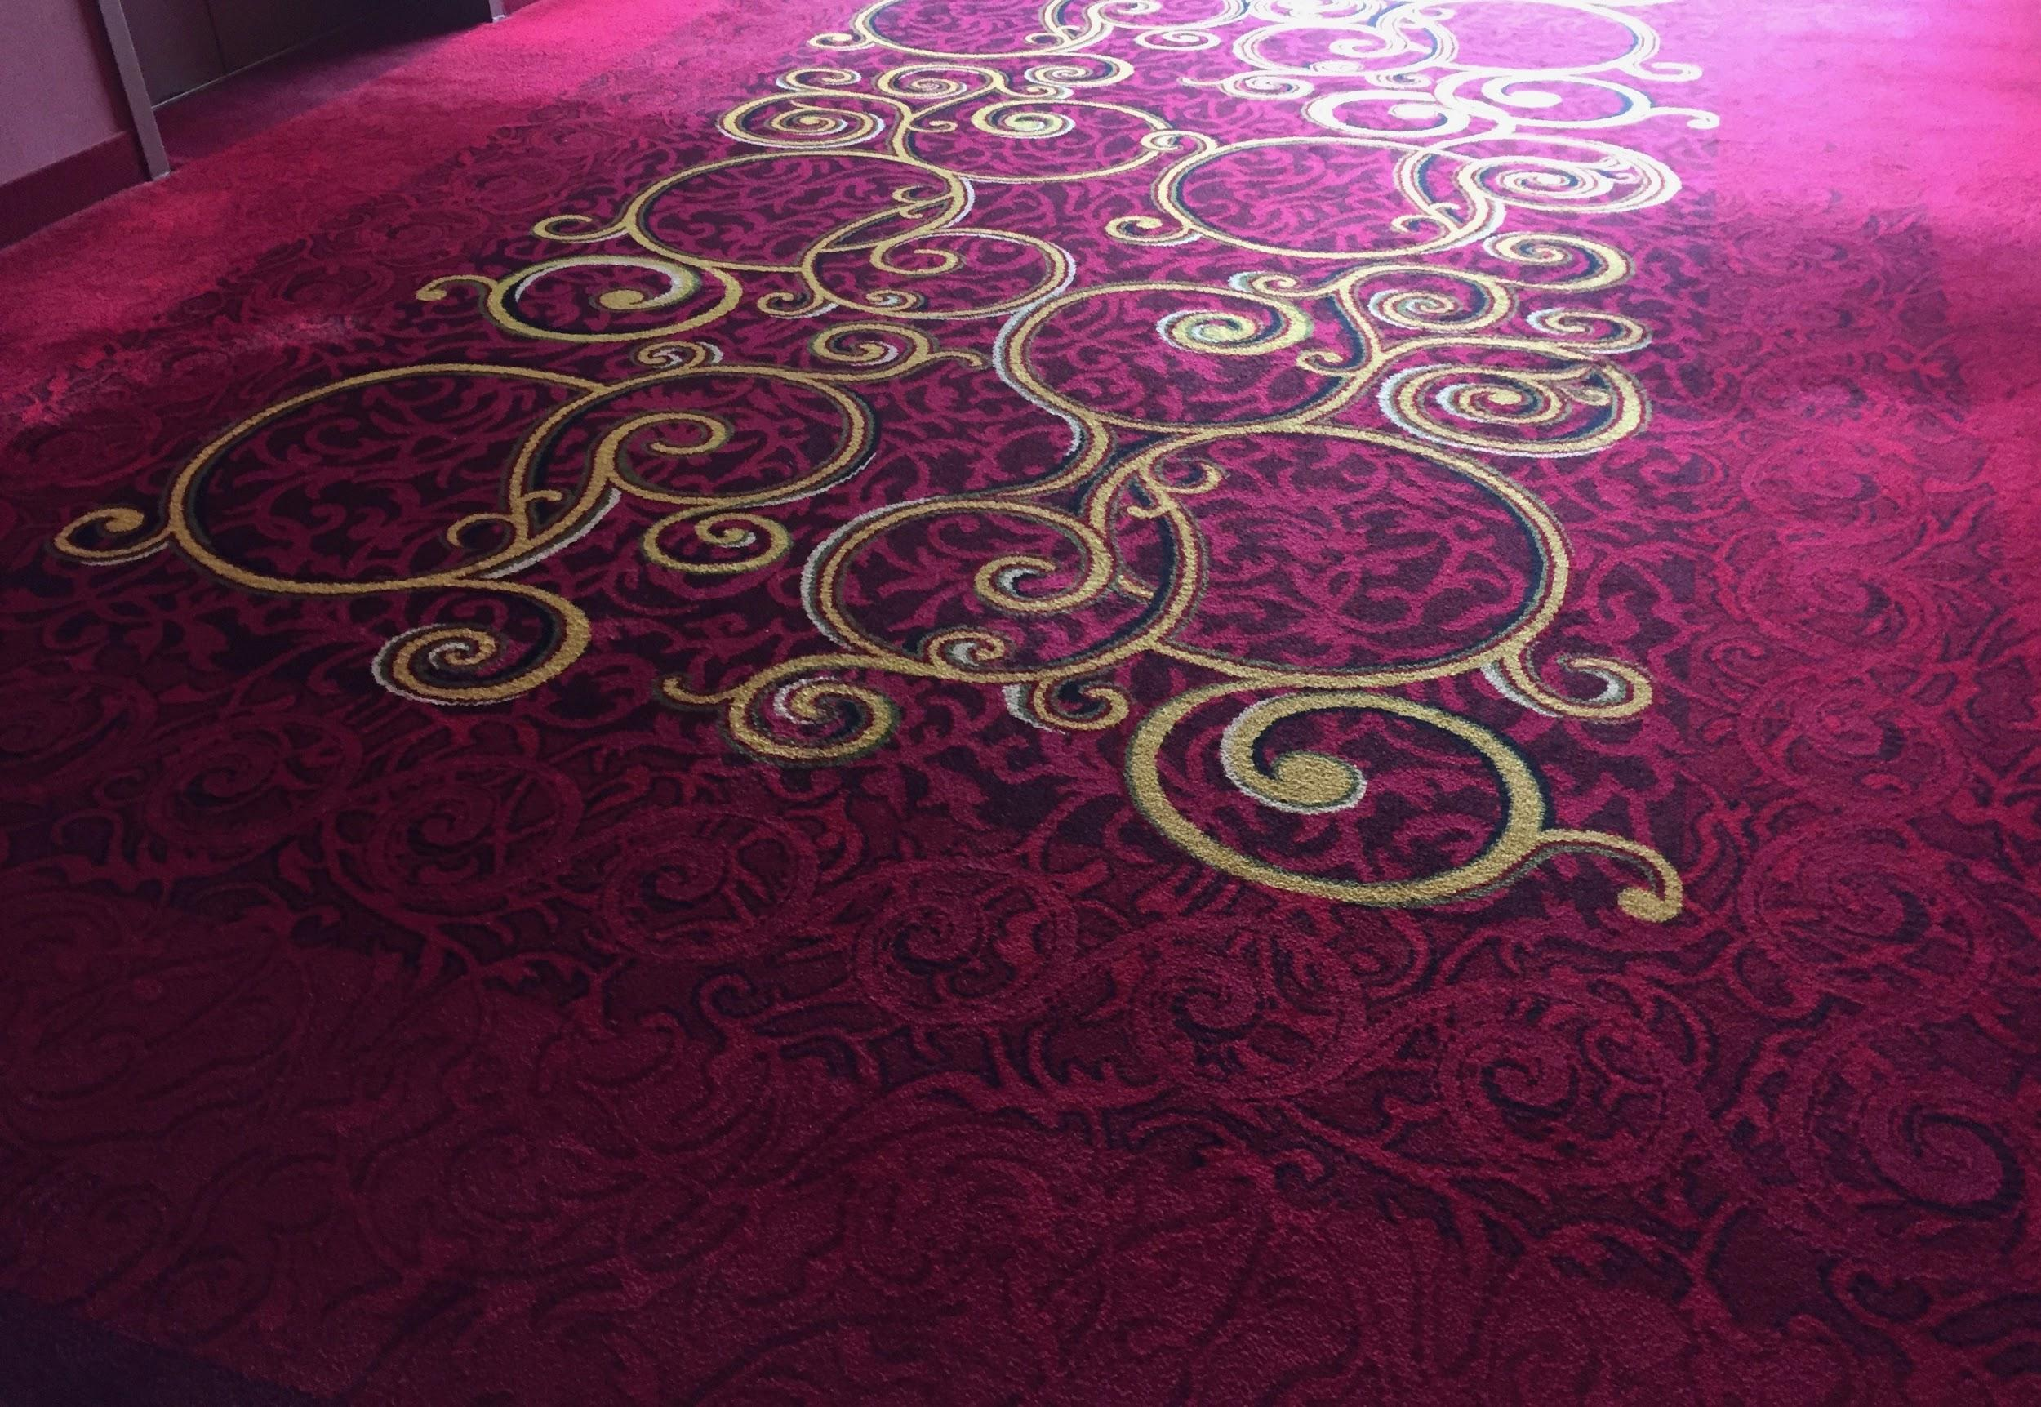
Section of carpet from the Marriott Hotel hallway

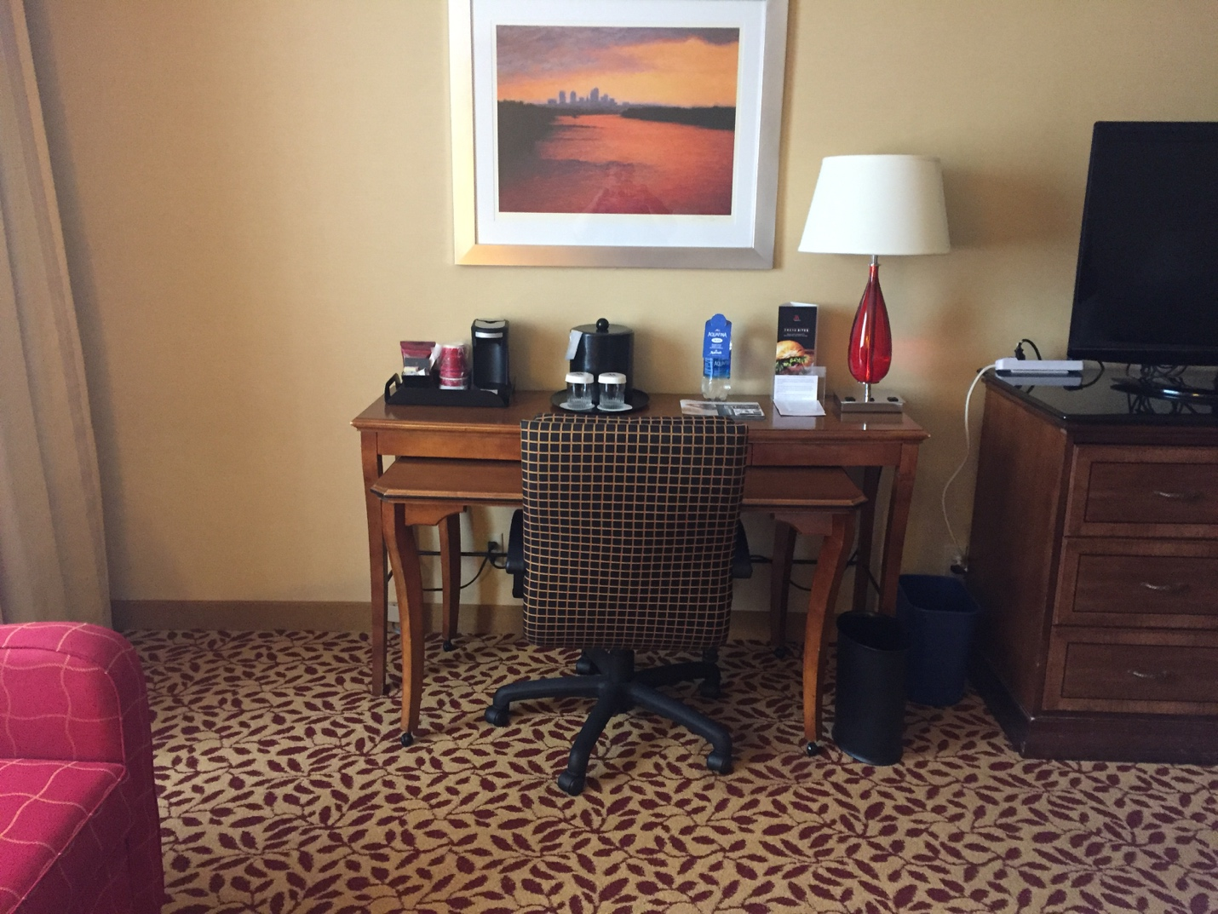
Workspace in a Marriott main tower room

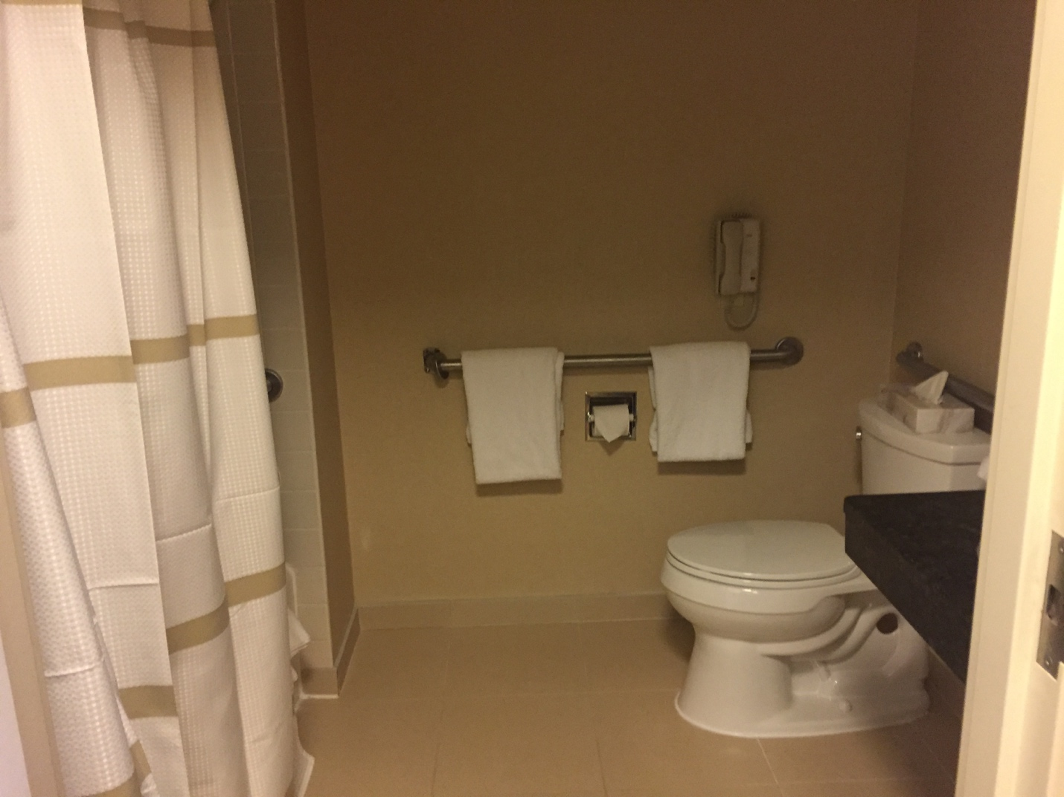
Tiled bathroom in one of the Marriott main tower accessible rooms

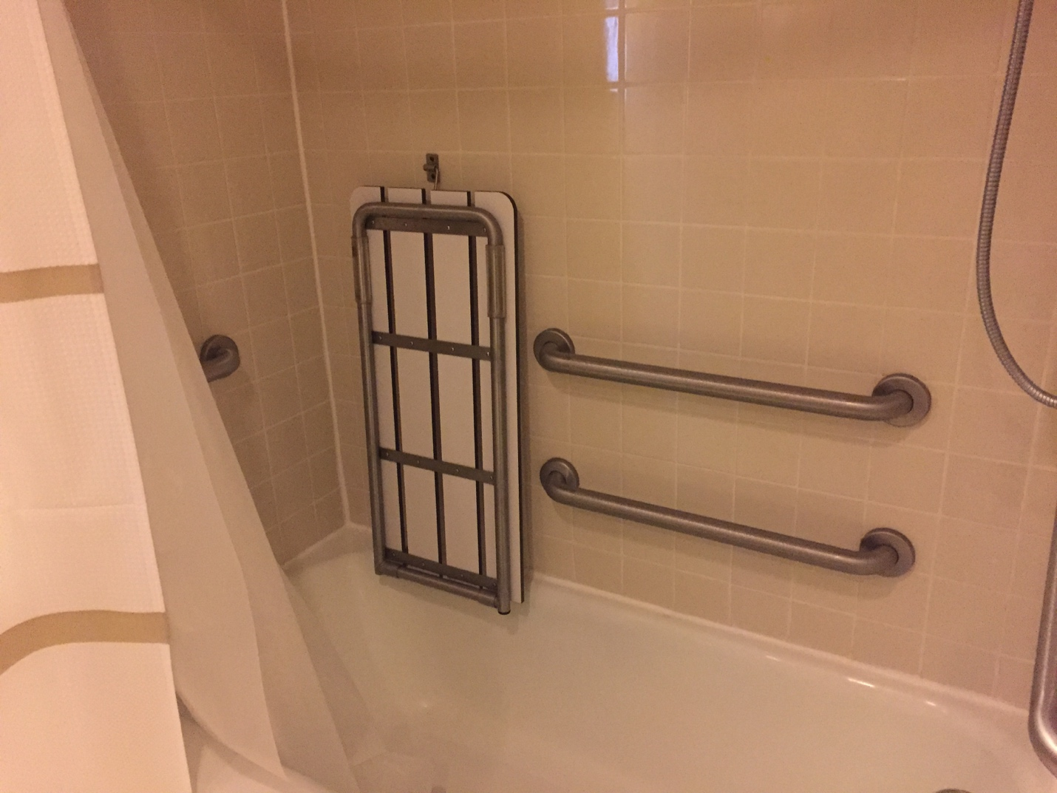
Bathtub/ shower in one of the Marriot main tower accessible rooms.

Some accessible bathrooms in the Muehlebach Tower of the Marriott hotel feature walk-in/wheel-in showers (image below) and a large sink. Guests should ask about shower options upon booking.

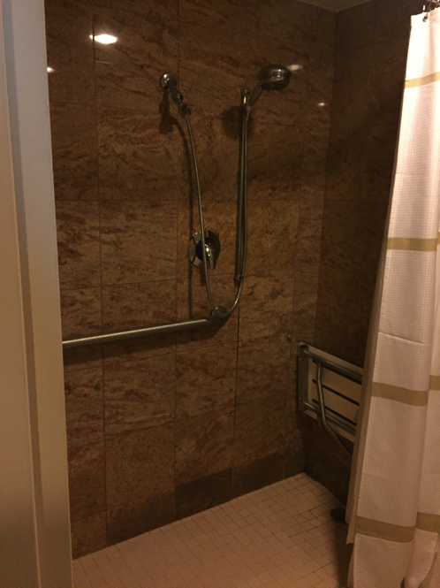
Walk-in/ wheel-in shower

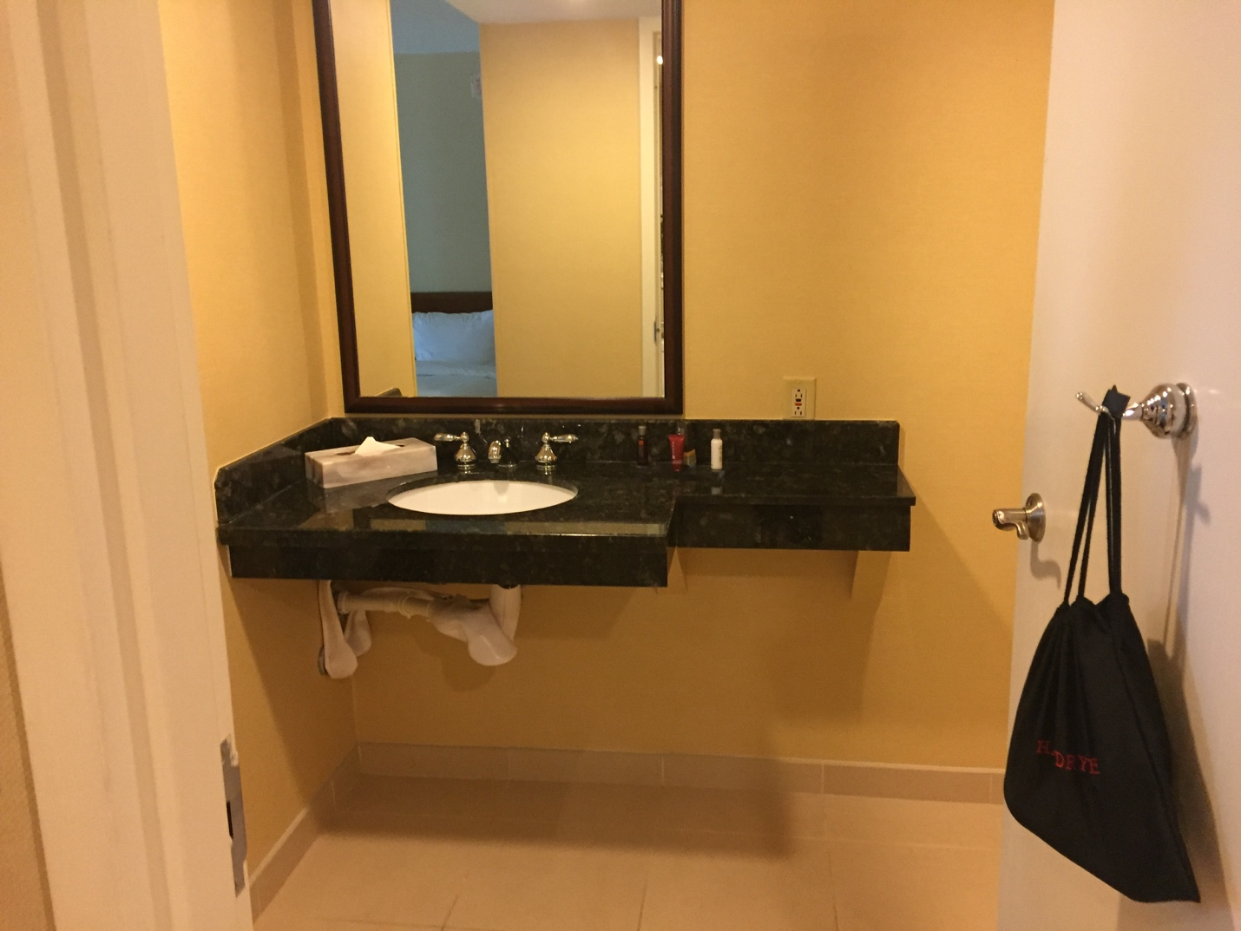
Separate sink in an accessible hotel room

Second Conference Hotel

Crowne Plaza, Kansas City Downtown

1301 Wyandotte Street
Kansas City, MO 64105
(816) 474-6664
19.5 miles from Kansas City International Airport
0.2 miles from Kansas City Marriott, Downtown: 1-minute walk or 3-minute drive. “Mostly flat” terrain, according to Google maps.

Overall Accessibility
The hotel is ADA compliant. There are both audible and visual alarms/alerts in hallways and public areas, as well as Braille signage. All elevators are also ADA compliant. More information about the hotel’s overall accessibility can be found by clicking the “Special Needs” tab on the Crown Plaza’s Features Page.

Accessible Guest Rooms
All accessible rooms are king suites, which have a wide door between rooms and open into a bedroom from a living room space. There is wide space for moving. The bathroom door is 28" wide and there’s a low counter inside the bathroom, a walk-in closet, and a tub/shower combination with one handrail. Elevators and rooms both have Braille signage. Carpet is generally low pile.

Parking & Transportation
There is no hotel-specific shuttle from the airport, but SuperShuttle services this hotel. The fee is $18 each way. Self parking is $10.00 per car, per day for event parking and $19.00 per car, per day for overnight guests. Valet parking is $14.00 per car, per day for event parking and $23.00 per car, per day for overnight guests.
Accessible self-parking, and van accessible self-parking are available. There are 16 wheelchair accessible parking spaces, but the doors from the elevator to the parking garage are not automatic.

Common Areas
The Crowne Plaza has a revolving door entrance, as well as a wide automatic door with a ramp. The lobby is quite spacious and includes a Starbucks (6:00 a.m. – 7:00 p.m.). Elevators and rooms have Braille signage, and the carpet throughout the hotel is generally low pile. However, the carpet is often striped and there are many places where a number of very different patterns meet.
There is also a bar (called City Bar) at the far end of the lobby area. The bar opens at 3:00 p.m. and closes at midnight. The bar includes both high top and lower tables. The lighting is somewhat dim in the evening.

Dining
Crowne Plaza’s in-house restaurant is City Grille, which serves breakfast (buffet from 6:00 a.m. until 10:30 & full breakfast until 11:00), lunch, and dinner. The restaurant is open until 11:00 p.m. Aside from salads, there are very few vegetarian or gluten-free options. The primary restaurant and buffet area are both quite roomy.
Third Conference Hotel

Aladdin (Holiday Inn Kansas City Downtown)
1215 Wyandotte Street
Kansas City, MO 64105
(816) 421-8888
22 miles from Kansas City International Airport
431 feet from Kansas City Marriott, Downtown: about a 1-minute walk or drive. “Mostly flat” terrain, according to Google maps.

Overall Accessibility
The hotel’s basic accessibility information can be found by clicking the “Accessibility” Icon on the Holiday Inn’s website.
While the hotel makes its best effort to be fully accessible, it’s an historic hotel which means that it’s generally pretty small/narrow. The rooms are a bit small, as are the entryway, hallways, check-in area, etc. Even the accessible rooms are a little narrow. Additionally, there’s only one accessible elevator. The other two elevators can (maybe?) accommodate a wheelchair, but likely only a single wheelchair. Also, anyone can use the only accessible elevator, so someone using a wheelchair or scooter might end up waiting.

There is a walkway to the Marriott, but it’s not fully accessible: it’s quite long and includes double doors that do not have accessible activation switches/push buttons. If accessing the walkway from the parking garage, there are steps that one would have to navigate. The doors at the end of the walkway to the Marriott are locked 6 p.m. to 6 a.m. Monday-Friday and are locked throughout the weekend.

Accessible Guest Rooms
There are 8 accessible rooms. Accessible rooms include standing shower-only option, with built-in, fold-down shower seat (see photo below). The carpeting in the room is generally low-pile, and the window curtain “pulls” include easy to grasp handles. Every room also has a Keurig coffee maker. The carpeting is generally low-pile. Room numbers have braille signage.

Common Areas
The entryway is rather cramped. It includes both marble and carpet, and a small strip of flooring trim between tile and carpet. The business center and fitness center would have trouble accommodating a standard-size wheelchair. There is a washer and dryer available for guest use (12:01 p.m. to 11:59 p.m.), but the area is quite small.

Dining
Unfortunately, the in-house restaurant (Zebra) is not fully wheelchair accessible: much of the seating is at the bottom of two to three steps. However, there is wheelchair accessible seating available. The buffet area might be difficult to access with a wheelchair or scooter, but the hotel manager assures us that one of the staff would be happy to assist by taking buffet orders and bringing food to the table. Zebra is open daily for breakfast and dinner, but is closed for lunch. Hours of operation are 6:00 a.m.-10:00 a.m. and 5:00 p.m. – 9:00 p.m.

There is also a small cocktail bar (Martini Loft) located on the Mezzanine overlooking the lobby of the hotel. There is only bar seating. They’re open from 4:00-11:00 p.m.

Parking & Transportation
There is no hotel-specific shuttle from the airport, but SuperShuttle services this hotel. The fee is $18 each way. Valet parking is $18 per car per day for overnight guests. While self-parking is technically available, it’s at the garage across the street. Guests will be charged each time they leave and return to the parking garage. There is access to parking, but some floors include negotiating a step-up off the parking garage floor and toward the elevator.

CONFERENCE ACTIVITY
Most conference panels, as well as the Access Table, Registration, Exhibit Hall, and Local Committee Table will be housed at the Kansas City Marriott, Downtown. Some events will be held at the Kansas City Convention Center.

The Convention Center is 0.2 miles from the Marriott hotel, an approximately 3-minute walk. There is also an underground walkway connecting the two building, but the walkway doors to the Marriott are locked between 6 p.m. and 6 a.m. and on the weekends.

Technology
Your requested technology devices (including projector and Internet access) should be available in your presentation room. You should provide your own dongles and other connection devices. Local Technology Committee members should be available for last-minute help should you encounter problems.

Many rooms will have microphones. Presenters are encouraged to use the microphone even if you feel it is not needed.

Kansas City Marriott, Downtown
200 West 12th St.
Kansas City, MO 64015
(816) 421-6800

Overall Accessibility
The Kansas City Marriott, Downtown includes two parts/towers: the Marriott Main Tower portion (also often just referred to as The Marriott) and the Muehlebach Tower. They are connected by a covered, carpeted walkway. Both are ADA compliant, although there are areas of the Muehlebach Tower that are not fully accessible. The Trianon level, for example, is technically accessible via elevator and electric lift, but both may require hotel staff to operate.

Volunteers and information, including assistance in finding locations throughout the conference, are available at the Accessibilities Table, located in the Basie Ballroom Foyer at the Kansas City Marriott Downtown. Service animals are welcome.

Note: the entire hotel seemed, when we toured, somewhat strongly scented. Additionally, the hotel manager couldn’t tell us an average temperature for the hotel.

Building Access and Parking
The main entrance to the Marriott has a large sliding automatic door. Valet parking drop-off is immediately in front of the main doors.

The hotel has on-site accessible self-service parking for $3 per hour or $18 per day. Valet parking is also available for $25 a day. The Auditorium Plaza Parking Garage (also known as the Barney Allis Plaza Parking Garage), located between 12th & 13th Streets and between Central & Wyandotte Streets, is 0.1 miles away. There is an underground tunnel from the garage to the hotel, but the walkway doors are locked between 6 p.m. and 6 a.m. and on the weekends.

Quiet Room
The Quiet Room will be located at the Marriott in the Taft Room on the Main Level Lobby in the Muehlebach Tower. Quiet rooms are intended to provide a quiet, calm space where convention attendees can spend time away from the noise, lights, and other stimuli of conference spaces. The quiet room is not available for conversations or meetings. The Quiet Room hours are Wednesday through Friday: 7:00 a.m.–9:00 p.m. and Saturday: 7:00 a.m.–5:00 p.m.

Wifi
Wifi is available in all common areas of The Kansas City Marriott Downtown. Wifi is also available in all session rooms, The network ID and password are CCCC2018.

Gender Neutral Restrooms
Gender Neutral Restrooms will be located in the following Marriott locations:
- Basie Ballroom Foyer across from Registration in the Marriott Tower
- Third Level Meeting Rooms in the Marriott Tower next to Jay McShann B
- Main Level Lobby in Muehlebach Tower across from the Colonial Ballroom
- Trianon Level in the Muehleback Tower across from Trianon A

Common Areas
Carpets throughout the Marriott are generally low-pile and a bit spongy. The patterns, though, are quite busy and change somewhat often. A few of the floors are tiled (images below).

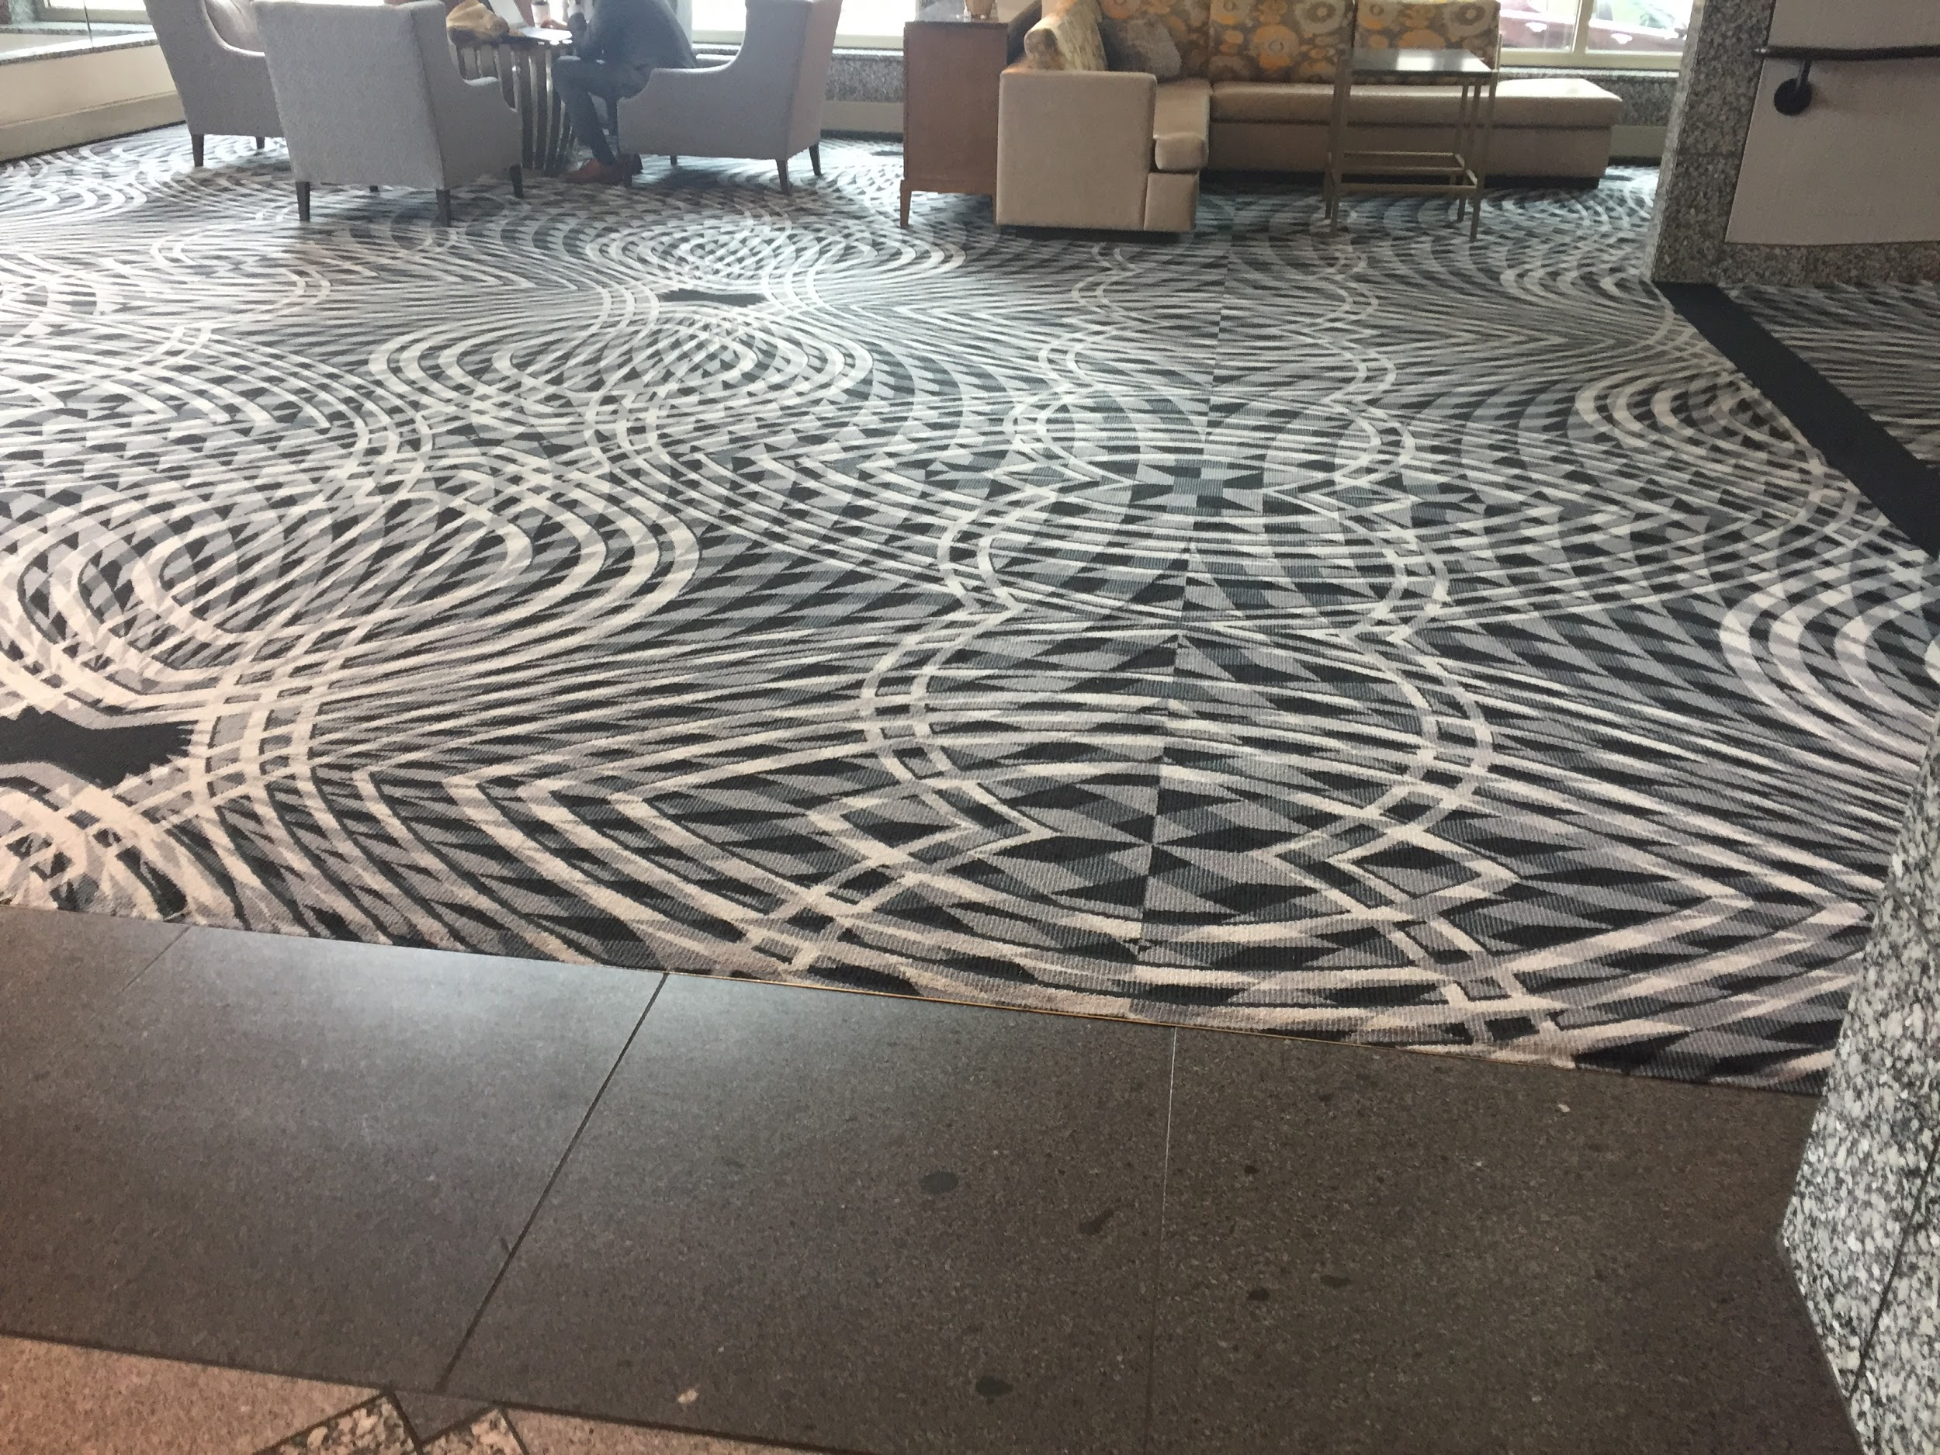
Flooring in Marriott hotel seating area.

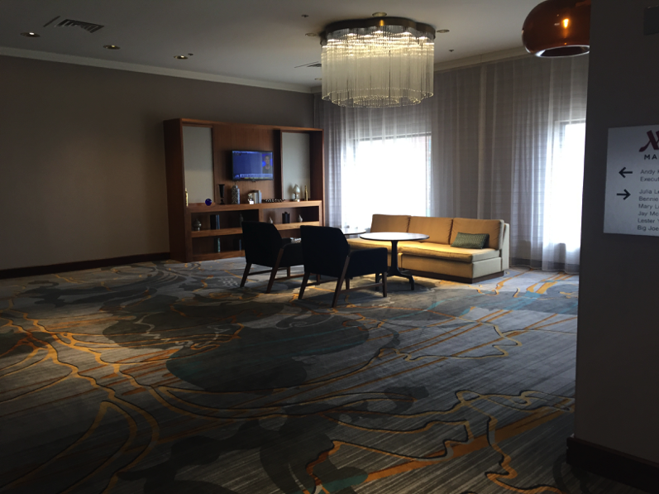
Seating area in Marriott hotel
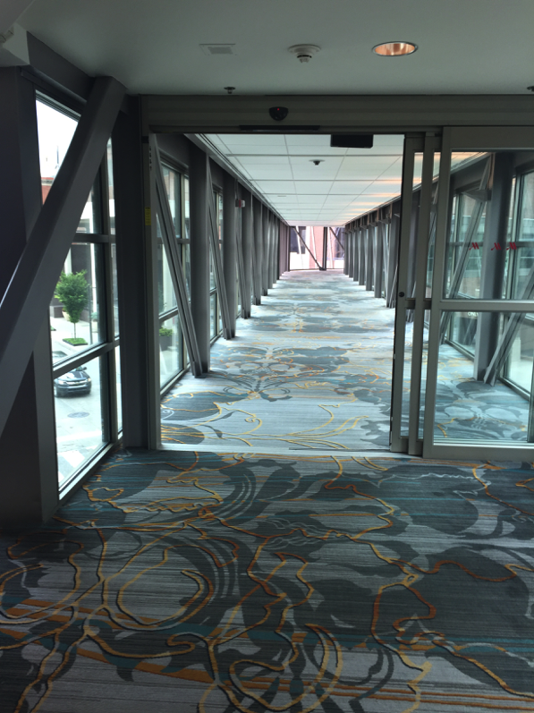
Walkway from the main tower of the Marriott hotel.

Conference Rooms
Conference rooms consist of several types of rooms: hard-wall rooms, rooms split by thick partitions that may allow some noise from the next room, and either full or partial ballrooms partitioned with moveable walls. There are both large and small conference rooms; all of them are carpeted and the carpets, although the patterns vary, are rather busy.

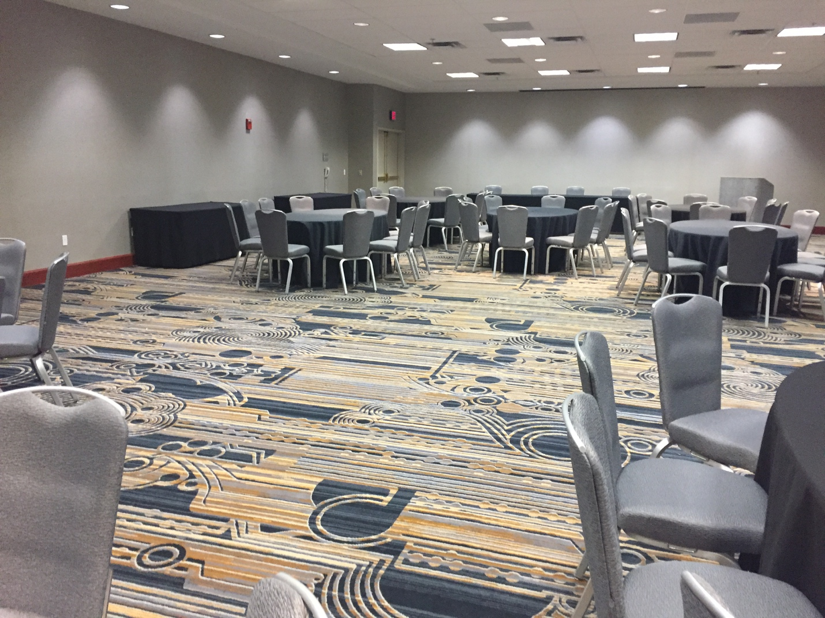
One of the larger conference rooms at the Marriott.

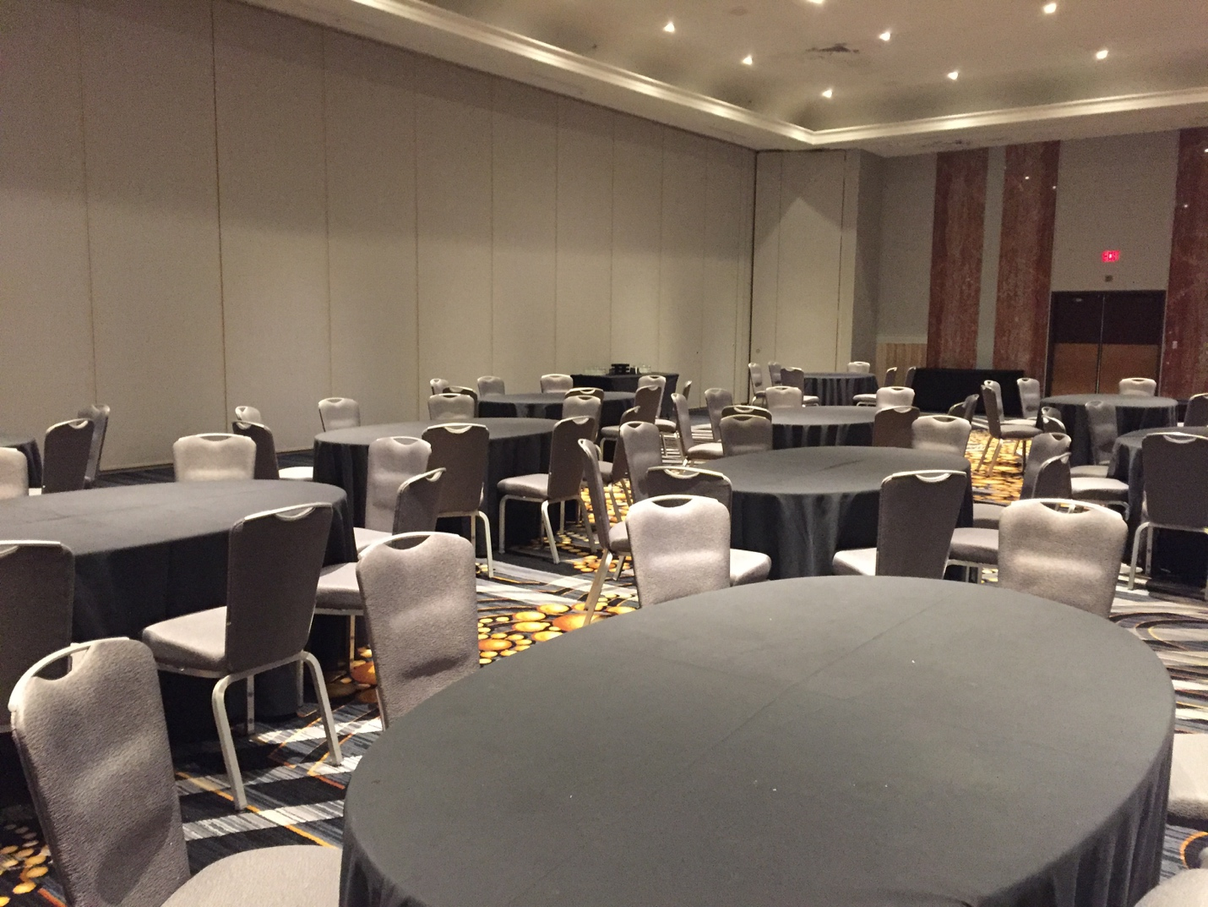
Another large conference room at the Marriott.

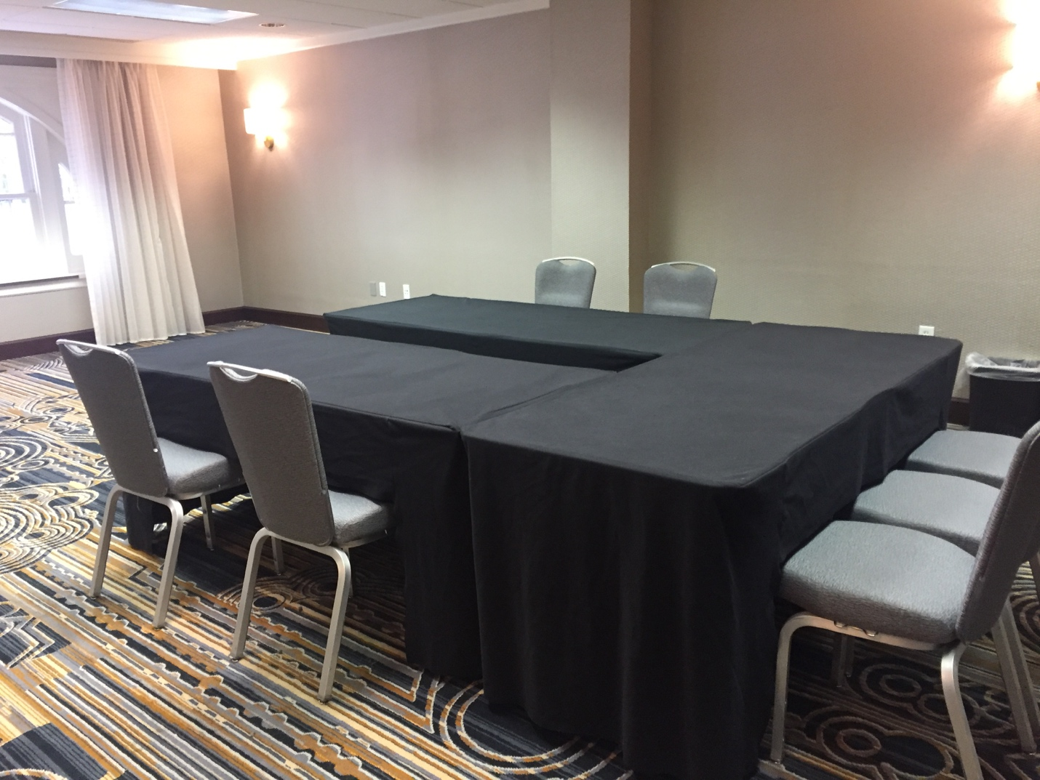
A smaller conference room at the Marriott hotel.

Kansas City Convention Center
301 West 13th Street, Suite 100
Kansas City, MO 64105
Phone: 816-513-5000
Toll-Free Phone: 800-821-7060

Parking
The Kansas City Convention Center does not have parking at the facility. The primary parking garage in the area is the Auditorium Plaza Parking Garage, also known as the Barney Allis Plaza Parking Garage, located between 12th & 13th Streets and between Central & Wyandotte Streets. There is an underground tunnel from the garage to the Convention Center. The cost for parking in this garage is $12/day. There is metered street parking in the area surrounding the Convention Center. During the hours between 8 am and 5 pm, available metered parking can be difficult to find.

Entrance
The ground-level entrance to the Convention Center is on the side of the building facing north at the southwest corner of 13th and Central Avenue. There are accessible doors located at this entrance as well as rotating doors. The outside of the building is labeled “Lobby 2200.” There are escalators to the left upon entering the Convention Center.

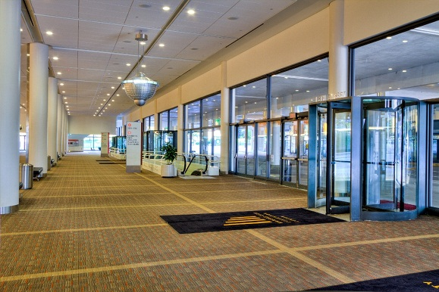
Lobby 2200 entrance of the Kansas City Convention Center. Photo is property of Kansas City Convention Center and Entertainment Facilities

Wheelchair Service
The Convention Center offers complimentary wheelchairs for conference attendees. Wheelchairs are available on a first come/first serve basis and cannot be reserved prior to arrival. Wheelchairs can be checked out at the Event Services Office on Level 1 of the Convention Center. There is no charge to borrow a wheelchair; however, a driver’s license is required and will be held until the wheelchair is returned. For wheelchair inquiries, call 816-513-5000.

Business Center
The Harvest Business Center is located near the 2200 Lobby of the Convention Center. They offer a variety of services for conference attendees including shipping, printing, scanning, copying, and internet workstations. Attendees may also purchase office supplies such as pens, flash drives, tape, phone chargers, and batteries.
- Hours: Monday through Friday, 8 am-5 pm.
- Phone Number: 816-513-5651

Gender Neutral Restrooms
Kansas City Convention Center
- Level 1 across from Rm 2213
- Level 2 across from 2502 B
- Level 2 next to 2501 A & B
- Level 3 across from 3501 D

Common Areas
The Convention Center has primarily brown and blue carpeting, overhead fluorescent lighting, tall windows with natural light in hallways, and high ceilings throughout. The amount of light in hallway areas with windows depends on the weather and time of day.

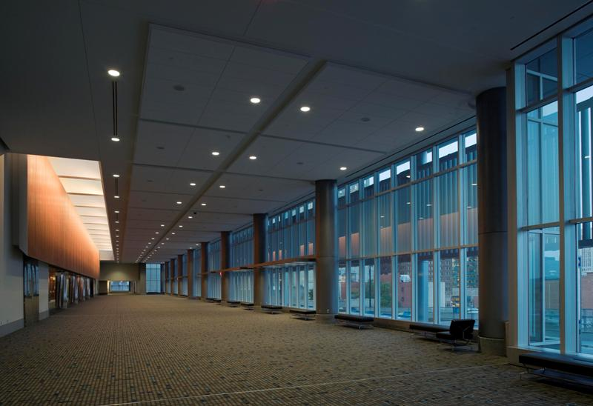
Lobby outside of Grand Ballroom/ Kansas City Convention Center. Photo is property of Kansas City Convention Center and Entertainment Facilities.

Meeting Rooms

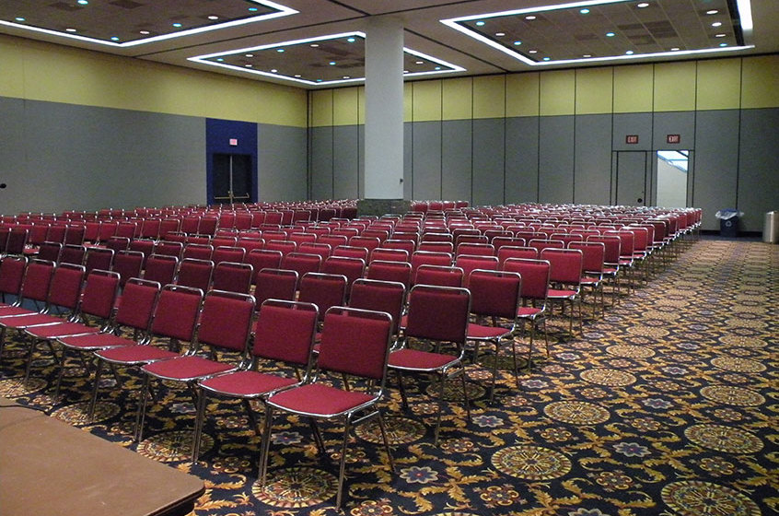
Large meeting room in the Convention Center. Photo is property of Kansas City Convention Center and Entertainment Facilities

Nearest Drugstores
CVS (.4 miles from Marriott)
921 Main Street
Kansas City, MO 64105
816-842-2514
Open: M-F 7:00 am - 7:00 pm, Sat 8:00 am – 6:00 pm, Closed Sun

Walgreens at Truman Center Hospital Hill (2 miles from Marriott)
2301 Holmes Street
Kansas City, MO 64108
816-471-2072
Store Open: M-F 8:00 am – 7:00 pm, Closed Sat and Sun

Local Committee Website
This website includes descriptions and direct links to Kansas City neighborhoods, restaurants, attractions, and activities. Accessibility information is often included in the description of a venue. Thanks so much to the local committee for all of their work.

Thanks
We’d like to thank the members of previous committees, whose hard work made this document possible. A special thank you to the 2016 CCCC Houston committee, whose guide we used as a template. Additionally, the work of the 2018 Hospitality Committee to include access information about Kansas City restaurants, attractions, and activities is very much appreciated. Thank you to Jane Greer who coordinated our on-site visits, to Stephanie Kerschbaum for feedback and encouragement, to Melissa Helquist whose technological skills made this document so much more accessible, and to all those who offered suggestions for revision.

