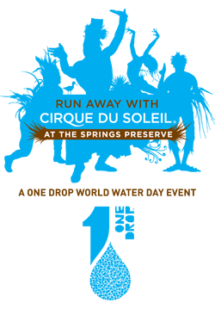
The Jim Berlin Memorial Run unfortunately will not be take place this year.
If you are among those disappointed by this news and would like an opportunity to walk or run for another good cause, we invite you to "Run Away with the Cirque du Soleil." The world famous Cirque performers will stage this unique and exciting event to foster water awareness on Saturday, March 16th, at the beautiful Springs Preserve, a natural oasis fewer than 5 miles from the conference site. Warm up and run alongside costumed Cirque characters as you compete in the 5k run ($40 registration fee) or enjoy the
scenery in the 1 mile fun walk ($30 registration fee). This is a family friendly
event. For more information, please visit the official event website.

